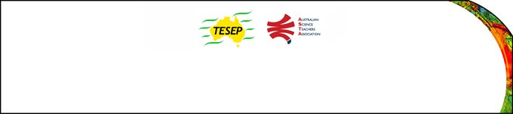
Workshops run from 9am to 4pm (unless otherwise indicated).
Teacher Earth Science Education Programme
Professional Development Workshop Series in Earth and Environmental Sciences
PD workshop registration form
Workshops are cancelled 5 working days prior if insufficient registrations are received.
Late registrations may be accepted if the workshop is running. Always contact us and ask!

PLEASE PRINT CLEARLY
Workshop name: |  |  | Date:
Venue: |  |  | State:

Name:
School:
Teaching area:
Phone (school): |  |  |  |  | (home): |  | (mobile):
Email: |  |  |  |  |  |  |  | Fax:
Home postal address:
Special dietary and other requirements:

Registration Fee: $55 per day applies for all registrants, except for Casual/Temporary Relief Teachers, Student Teachers, unemployed and under-employed teachers, where a maximum of $55 for one or two day workshop and associated field day will apply. To claim the discount please tick the box and state your reason for the claim:
Yes I would like to claim the discount because I am

Email or fax form to ASTA (office manager – Michelle Lollback). Send the non-refundable* registration fee (includes GST) to Australian Science Teachers Association (ABN 87 902 882 824)
Payment can be made by direct bank transfer or cheque/money order
Include your name and workshop details with payment (e.g. TESEP PD9 WA July 16 J. Citizen)
*The fee is transferable to another PD workshop or for another teacher to substitute
Fax: | 02 6282 9477 | Email: | officemanager@asta.edu.au
Address: | TESEP  c/o ASTA  PO Box 334  Deakin West ACT 2600 | Account details: | Australian Science Teachers Association (ASTA)  BSB: 082 902  Account No: 556 705 700
Please tick if you require an invoice and provide the correct address for invoicing if different to your home address:

Please also email a copy of your completed form to TESEP registration: registration@tesep.org.au

A certificate will be issued by ASTA which states the number of PD attendance hours.
For registration inquiries contact registration@tesep.org.au
www.tesep.org.au www.asta.edu.au
Please Note: Payment of subsidies and issuing of a certificate are conditional on workshop payment.

