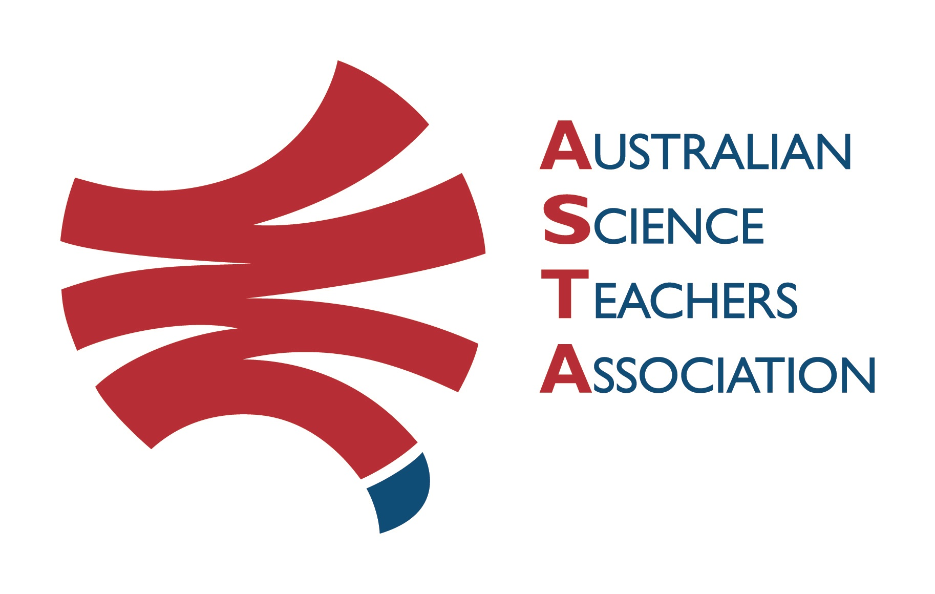
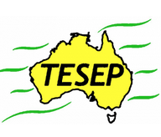

Professional Development Workshop Series in Earth and Environmental Science
TESEP PRESENTS: AFTER SCHOOL PROFESSIONAL DEVELOPMENT (PD)

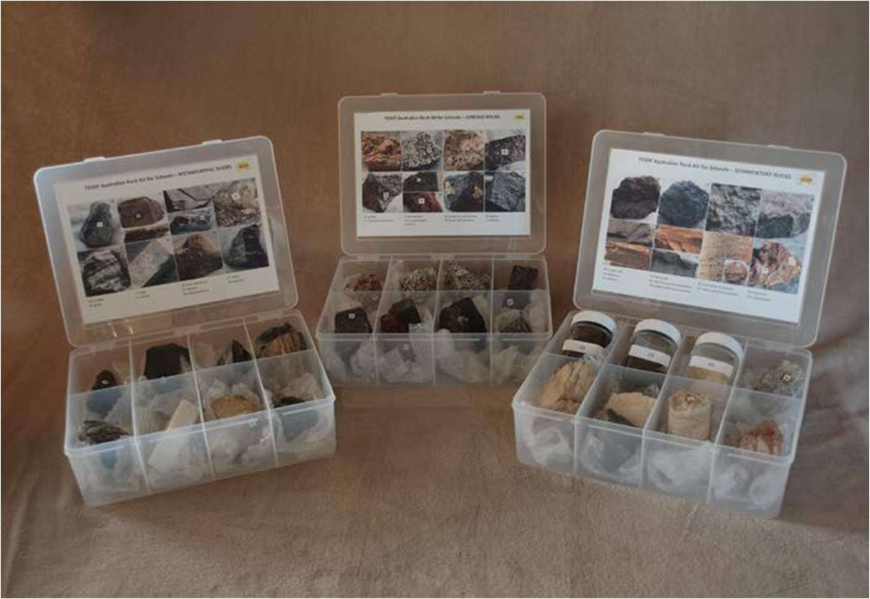
RocksExpo PD topics:
- Rocks and how to use the TESEP rock kit & teaching pack
- Plate tectonics and the geology of the Central West
- Critical minerals
The RocksExpo experience includes–
1. PD workshops – After-school professional development workshops for teachers (sessions @ $25 per school for visiting teachers, FREE to host-school teachers or teachers from other sponsored schools).
2. Certification – a Australian Science Teacher Association (ASTA) PD workshop certificate.
3. FREE rock kit – Host to receive a FREE rock kit and Plate Tectonics poster.
4. Introductory RocksExpo feature How to Use the Rock Kit and Teaching Pack (e.g. how to relate rock kit rocks to rock stories, 3D rendered samples, virtual thin sections and virtual outcrops).
Teacher Earth Science
Education Programme
5 Subsequent RocksExpo topics can be chosen from TESEP’s “The Challenging Earth” series (to
be run twice a year at host schools).
6. Excursions – possible second-year trip to field outcrops, mine sites, minerals museums etc.
7. Incursions - classroom lessons (each max. 30 students) with teachers.
School: Dubbo College Senior Campus

Date: 10 December, 9am – 4pm (Refreshments will be provided), 11 December, 8am-noon fieldtrip

School Facilitator: James Eddy

Presenters:
Associate Professor Malte Ebach has a Masters in Geoscience, a PhD in palaeobiogeography, and has two decades of research and teaching experience at university level. He specialises in palaeontology and palaeobiogeography. Simone Meakin has an Honours Degree in Geology from the University of Adelaide and worked briefly in oil exploration before joining the NSW Government to do geological field mapping and eventually apply this to science publishing and outreach. Alex Cherry is a senior exploration geologist with Alkane Resources, based in Dubbo. He manages the exploration for gold, copper and whatever else may be present between Narromine and Parkes.

Booking form
Professional Development Workshop Series in Earth and Environmental Science
Name:
School:
Teaching Area:
Phone (School):
Email:
Home postal address:
Special Dietary and other requirements:

Registration fee: Free for teachers working at the host school and other sponsored schools. $25 per workshop for each other school.

tesep.org.au
asta.edu.au
please print clearly
Workshops:  - Round and round with rocks and minerals  - Plate tectonics and geology of the Central West  - Critical minerals (and Sunday field trip) | Date:  10-11 December 2022
Venue: Dubbo College Senior Campus, Tony McGrane Place, Dubbo | State: NSW

Email or fax form to ASTA (office manager – Michelle Lollback). Send the non-refundable* registration fee (includes GST) to Australian Science Teachers Association (ABN 87 902 882 824).
Payment can be made by direct bank transfer or cheque/money order. Please include your name and workshop details with payment (e.g. TESEP PD9 NSW July 20 J. Citizen).
*The fee is transferable to another PD workshop or for another teacher to substitute
Email: officemanager@asta.edu.au | Address: TESEP ℅ ASTA  PO Box 334 Deakin West ACT 2600
Account Details: Australian Science Teachers Association (ASTA) BSB: 082 902 Account No: 556 705 700

Please tick here if you require an invoice ☐ and provide address if different from the one above:

A certificate will be issued by ASTA which states the number of PD attendance hours. For registration inquiries contact registration@tesep.org.au
Please Note: Issuing of a certificate is conditional on workshop payment.

