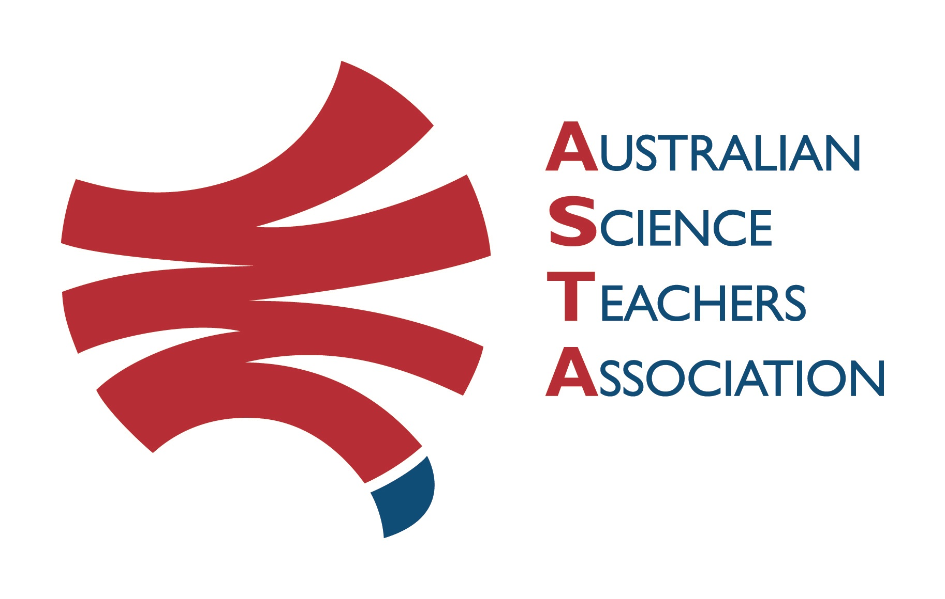
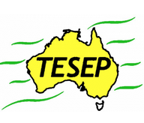

Professional Development Workshop Series in Earth and Environmental Science
TESEP PRESENTS: AFTER SCHOOL PROFESSIONAL DEVELOPMENT (PD)

RocksExpo 2-PD Introducing Our Dynamic Planet:
Rocks (and how to use the TESEP rock kit) &
Critical Minerals (key minerals - the E-car, wind turbine magnets, smart screens)
School: Orroroo Area School, 5 West Terrace, Orroroo, SA
Meeting Room: attendees to go to The Meeting Room
Date: Wed 8 June 2022, 4:00pm – 5:30pm Rocks, supper - Antarctica - short videos for students, 6:00pm – 8:00pm Critical Minerals
School Facilitator: Jacinta Ferguson

The RocksExpo experience includes–
1. Incursions – classroom lessons with students and teachers.
2. PD workshops – After-school professional development workshops for teachers (2-hour sessions @ $25 per attendee for visiting teachers, FREE to host-school teachers).
3. Certificate of attendance – A certificate of hours and workshop outcomes will be issued.
4. FREE rock kit – Host to receive a FREE rock kit and Plate Tectonics poster.
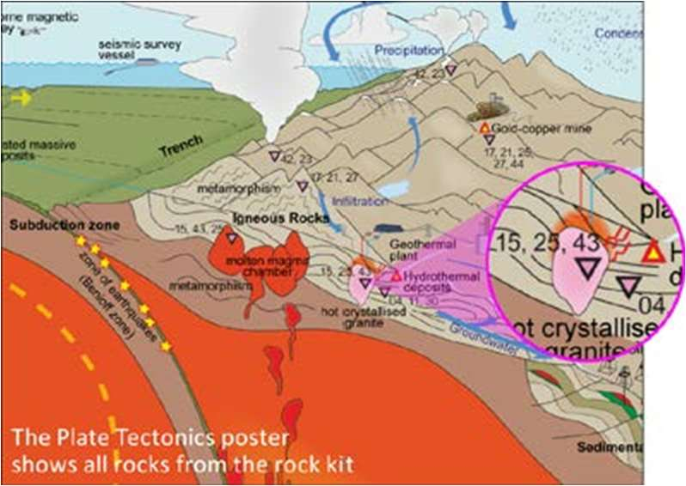
5. Introductory RocksExpo feature How to Use the Rock Kit and Teaching Pack (e.g. how to relate rock kit rocks to rock stories, 3D rendered samples, virtual thin sections and virtual outcrops).
Teacher Earth Science
Education Programme
6. Subsequent RocksExpo topics can be chosen from TESEP’s “The Challenging Earth” series (to
be run twice a year at host schools).
7. Excursions – possible second-year trip to field outcrops, mine sites, minerals museums etc.
Presenter:
Philip Sansom – Tasmanian TESEP Coordinator, former teacher and geologist in the coal and
petroleum exploration industry. Philip maintains an active interest in all areas of earth science.
Rob Kirk – keen palaeontologist & sedimentary basin geophysicist, with many a geo-story to tell.
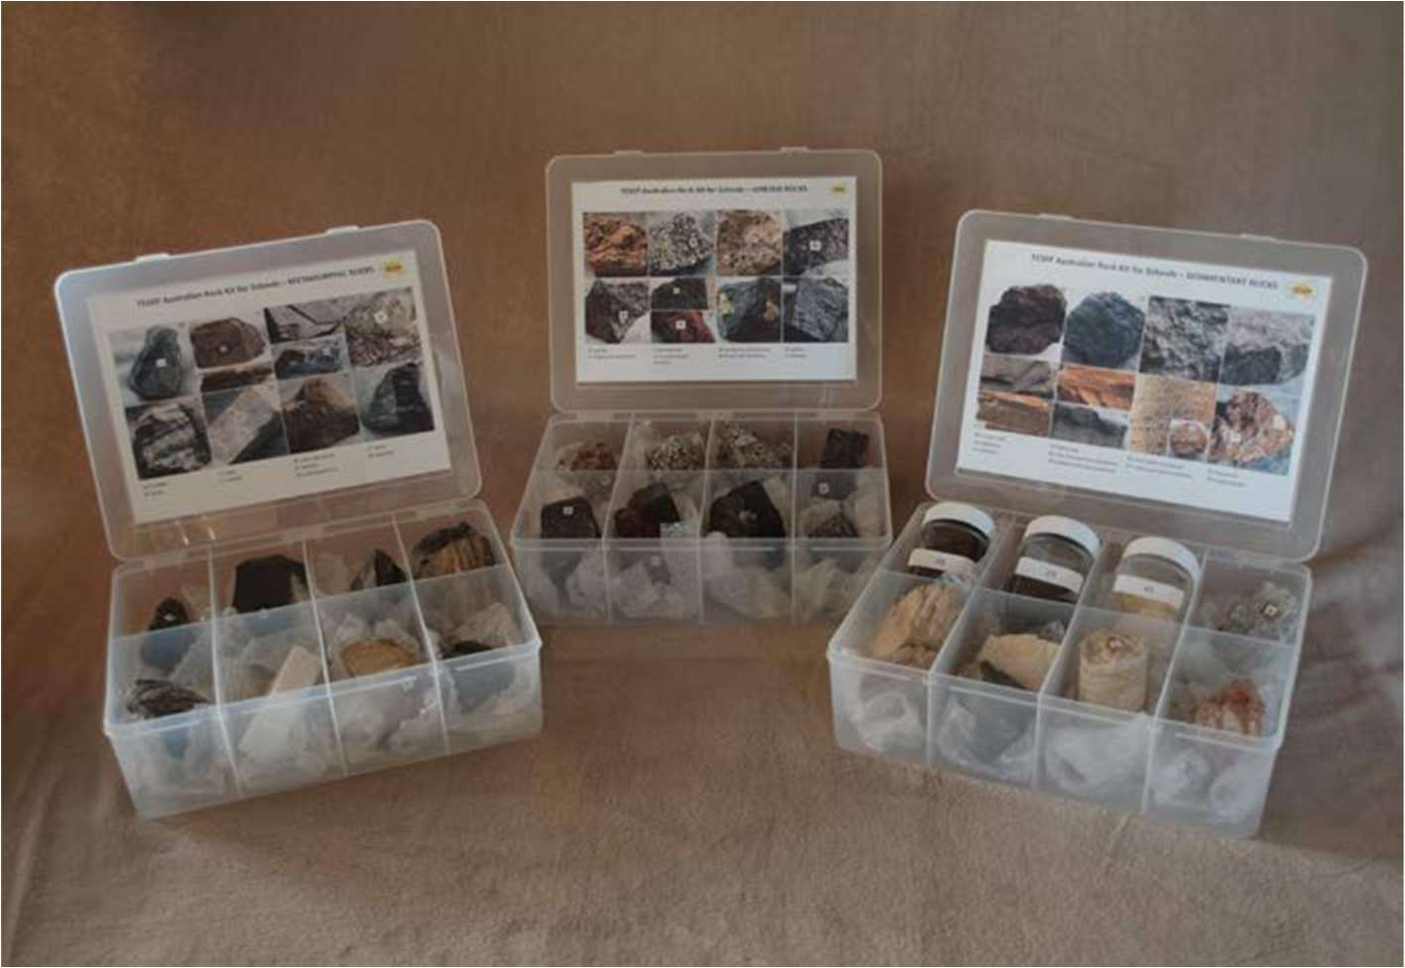

tesep.org.au

asta.edu.au

Booking form
please print clearly
Workshop: 2-PD Rocks and Critical Minerals | Date: Wed 8 June 2022
Venue: Orroroo Area School | State: SA

Registration fee: Free for teachers working at the host school and other sponsored schools. $25 per attendee from each other school.

Name:
School:
Teaching Area:
Phone (School):
Email:
Home postal address:
Special Dietary and other requirements:

Email or fax form to ASTA (office manager – Michelle Lollback). Send the non-refundable* registration fee (includes GST) to Australian Science Teachers Association (ABN 87 902 882 824).
Payment can be made by direct bank transfer or cheque/money order. Please include your name and workshop details with payment (e.g. TESEP PD9 NSW July 20 J. Citizen).
*The fee is transferable to another PD workshop or for another teacher to substitute
Email: officemanager@asta.edu.au | Address: TESEP - ASTA  PO Box 334 Deakin West ACT 2600
Account Details: Australian Science Teachers Association (ASTA) BSB: 082 902 Account No: 556 705 700

Please tick here if you require an invoice ☐ and provide address if different from the one above:

A certificate will be issued by ASTA which states the number of PD attendance hours. For registration inquiries contact registration@tesep.org.au
Please Note: Issuing of a certificate is conditional on workshop payment.

Professional Development Workshop Series in Earth and Environmental Science

