Professional Development Workshop Series in STEM / Earth and Environmental Science

at The Gap SHS on Wednesday 06 November 2024

**12.20 to 1.30pm: Integrated teaching - Rocks and Critical Minerals.** Introduction to integrated teaching with plate tectonics/rock cycle - the TESEP kits and teaching resources: with rock/mineral stories, 3D renders/virtual teaching. Hands-on activities to describe rocks and critical minerals, rock cycle examples and their use in society, by First Nations Australians and for the energy transition. **Curriculum topics for years 6 to 9.**

**1.30 to 3.30pm: Life, Fossils, Volcanic-Climate events & the 5 Big Extinctions** – Integrated teaching of extinction event/climate -volcanic events/fauna-flora changes and palaeogeography/livability of the planet, in a plate tectonic context.Curriculum **topics for years 9 to 12, with biology, geography, climate science, STEM/physics and atmospheric chemistry crossover.**

|  |  |
| --- | --- |
| **Location:** The Gap SHS, 1020 Waterworks Rd, The Gap, Qld 4061 | **Meeting room**: Attendees to attendees to go to the front desk to be directed to Meeting Room |
| **Date:** Wednesday 06 November 2024 | **Time:** 12:20pm to 3:30pm |
| **School Facilitators:** Kim Hoe | **Refreshments:** Afternoon tea provided |
| **Presenter:** Phil Gilmore is a TESEP regional coordinator, and a geoscientist with over 25 years of experience and expertise in geological mapping and geodynamics, mineral systems and exploration, outreach and geotourism. | |

**The TESEP RocksExpo experience includes:**

1. **PD workshops**: after-school professional development workshops for teachers.
2. **Certificate of attendance**: a certificate of hours and workshop outcomes will be issued.
3. **FREE rock kit**: host school to receive a FREE rock kit and Plate Tectonics poster.
4. **Rock and Critical Mineral Kit Teaching Packs**: how to use the kits and resources (e.g. how to relate rock kit rocks to rock stories, 3D rendered samples, virtual thin sections and virtual outcrops).
5. **Rock checks of school collections:** to check labelling and suitability of existing school collections.
6. **Incursions:** classroom lessons with students and teachers.

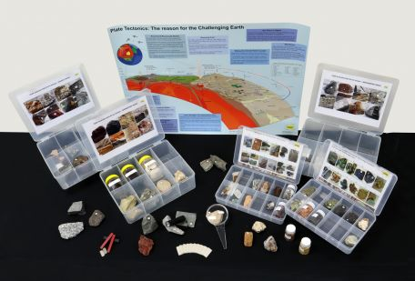

To register for a workshop:

1. Please complete the following form and email to: [office@asta.edu.au](mailto:office@asta.edu.au)
2. You will be issued with an invoice by ASTA for payment by direct bank transfer or credit card.

|  |  |
| --- | --- |
| **WORKSHOP DETAILS** | |
| Two x Professional Development Workshops at The Gap SHS on Wednesday 06/11/2024, 12.20pm to 3:30pm.   * Rocks/rock kit/plate tectonics integrated story * Life, Fossils, Volcanic-Climate Events & the 5 Big Extinctions   Please select from the options below:  I work at the host school or another sponsored school (no cost).  I work at another school ($50 per attendee).  I would like to apply for half-day Casual Relief of $220 (excl. GST). 4 available, 1 per school, on application.  (School to invoice TESEP, once relief funding approved by TESEP). | |
| **YOUR DETAILS** | |
| Name: | School: |
| Teaching area: | Phone (school):  Phone (mobile): |
| Email: | |
| Postal address (for certificate): | |
| Dietary or other requirements: | |
| **PAYMENT DETAILS** | |
| The registration fee for each workshop / field trip is non-refundable – though the fee is transferable to another PD workshop or for another teacher to substitute. The fee is GST inclusive.  An invoice will be emailed to you by the ASTA (Australian Science Teachers Association, ABN 87 902 882 824). The invoice includes details for payment by direct bank transfer or by credit card. Contact ASTA if any queries: [office@asta.edu.au](mailto:office@asta.edu.au) | |
| **CERTIFICATE OF PARTICIPATION** | |
| A certificate will be issued by ASTA which states the number of PD attendance hours. Please note that issuing of a certificate is conditional on workshop payment. | |

Please contact us if any queries or for more information!