Professional Development Workshop Series in STEM / Earth and Environmental Science

at Hastings Secondary College, Tuesday 05 November 2024

**1.30 to 2.45pm: Rocks and Critical Minerals.** Introduction to the TESEP kits and teaching resources: integrated teaching of rocks/minerals in the plate tectonics and rock cycle context, with rock/mineral stories, 3D renders/virtual teaching. Hands-on activities to describe rocks, rock cycle examples, and their use in society, by First Nations Australians and for the energy transition. **Curriculum topics for years 6 to 9.**

**3.00 to 5.00pm: Energy and the Energy Transition Rocks and Critical Minerals.** Explores the path to Net Zero, by comparing different energy types, outlines what are critical minerals, examines the properties of critical minerals that make them suitable for renewable energy and our high technology lives, and discusses the geological processes to critical minerals. Curriculum **topics for years 9 to 12, with STEM, physics and chemistry crossover.**

|  |  |
| --- | --- |
| **Location:** **Hastings Secondary College**, 16 Owen St, Port Macquarie NSW 2440 | **Meeting room**: Attendees to attendees to go to the front desk to be directed to Meeting Room |
| **Date:** Tuesday 05 November 2024 | **Time:** 1.30pm to 5pm |
| **School Facilitators:** Lisa Hall, Diana Harris | **Refreshments:** Afternoon tea/light supper provided |
| **Presenter:** Phil Gilmore is a TESEP regional coordinator, and a geoscientist with over 25 years of experience and expertise in geological mapping and geodynamics, mineral systems and exploration, outreach and geotourism. | |

**The TESEP RocksExpo experience includes:**

1. **PD workshops**: after-school professional development workshops for teachers.
2. **Certificate of attendance**: a certificate of hours and workshop outcomes will be issued.
3. **FREE rock kit**: host school to receive a FREE rock kit and Plate Tectonics poster.
4. **Rock and Critical Mineral Kit Teaching Packs**: how to use the kits and resources (e.g. how to relate rock kit rocks to rock stories, 3D rendered samples, virtual thin sections and virtual outcrops).
5. **Rock checks of school collections:** to check labelling and suitability of existing school collections.
6. **Incursions:** classroom lessons with students and teachers.

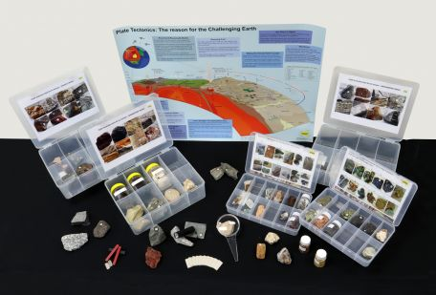

To register for a workshop:

1. Please complete the following form and email to: [office@asta.edu.au](mailto:office@asta.edu.au)
2. You will be issued with an invoice by ASTA for payment by direct bank transfer or credit card.

|  |  |
| --- | --- |
| **WORKSHOP DETAILS** | |
| Two x Professional Development Workshops at Hastings Secondary College, 05/Nov/2024, 2.30pm to 6pm.   * Rocks/rock kit/plate tectonics integrated story 2:30-3:50pm * Energy & the Energy Transition 4pm-6pm   Please select from the options below:  I work at the host school or another sponsored school (no cost).  I work at another school ($50 per attendee). | |
| **YOUR DETAILS** | |
| Name: | School: |
| Teaching area: | Phone (school):  Phone (mobile): |
| Email: | |
| Postal address (for certificate): | |
| Dietary or other requirements: | |
| **PAYMENT DETAILS** | |
| The registration fee for each workshop / field trip is non-refundable – though the fee is transferable to another PD workshop or for another teacher to substitute. The fee is GST inclusive.  An invoice will be emailed to you by the ASTA (Australian Science Teachers Association, ABN 87 902 882 824). The invoice includes details for payment by direct bank transfer or by credit card. Contact ASTA if any queries: [office@asta.edu.au](mailto:office@asta.edu.au) | |
| **CERTIFICATE OF PARTICIPATION** | |
| A certificate will be issued by ASTA which states the number of PD attendance hours. Please note that issuing of a certificate is conditional on workshop payment. | |

Please contact us if any queries or for more information!