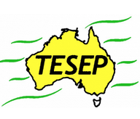

Professional Development Workshop Series in Earth and Environmental Science

TESEP PRESENTS: AFTER SCHOOL PROFESSIONAL DEVELOPMENT (PD)

**Thursday 19 December 2024, 8:30am – 12noon 2-PD ASHCROFT HS**

**Critical Minerals (renewable energy/electric car/batteries/recycling), yr 6-12**

**(Physics/Chemistry/STEM crossover)**

**Life, Fossils & the 5 Big Extinctions (Aust fossil changes through time, big extinctions, integrated plate tectonics/climate/volcanic events), yr 9-12 (crossover with Biology/Geography)**

**School:** **Ashcroft High School**, 108 Maxwells Ave, Ashcroft, NSW 2168

**Meeting Room:** Sign in at front office and get directed to meeting room

**Date**: **Thursday 19 December 2024** PD workshop, BYO lunch, morning tea provided

**Facilitator**: Melissa Duck

1. PD workshops – After-school professional development workshops for teachers (2-PD sessions @ $50 per attendee for visiting teachers, FREE to host-school teachers).

2. ASTA Certificate of attendance – A certificate of hours and workshop outcomes will be issued.

3. FREE rock kit or critical mineral kit – Host to receive a FREE rock or mineral kit and Plate Tectonics poster.

4. Introductory RocksExpo feature How to Use the Rock Kit, Critical Mineral Kit and Teaching Packs (e.g. how to relate rock kit rocks to rock stories, 3D rendered samples, virtual thin sections and virtual outcrops).



Teacher Earth Science

Education Programme

5. Subsequent RocksExpo topics can be chosen from TESEP’s “The Challenging Earth” series 2

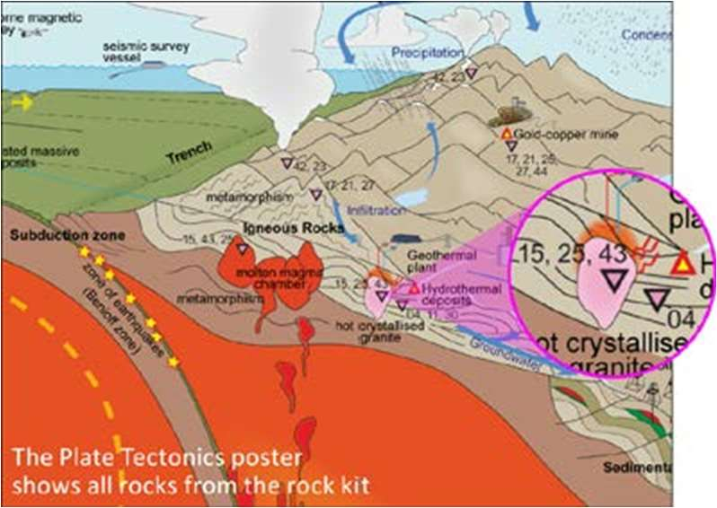**Presenter: Malte Ebach** is an experienced fossil geologist (palaeontologist) and NSW educator.

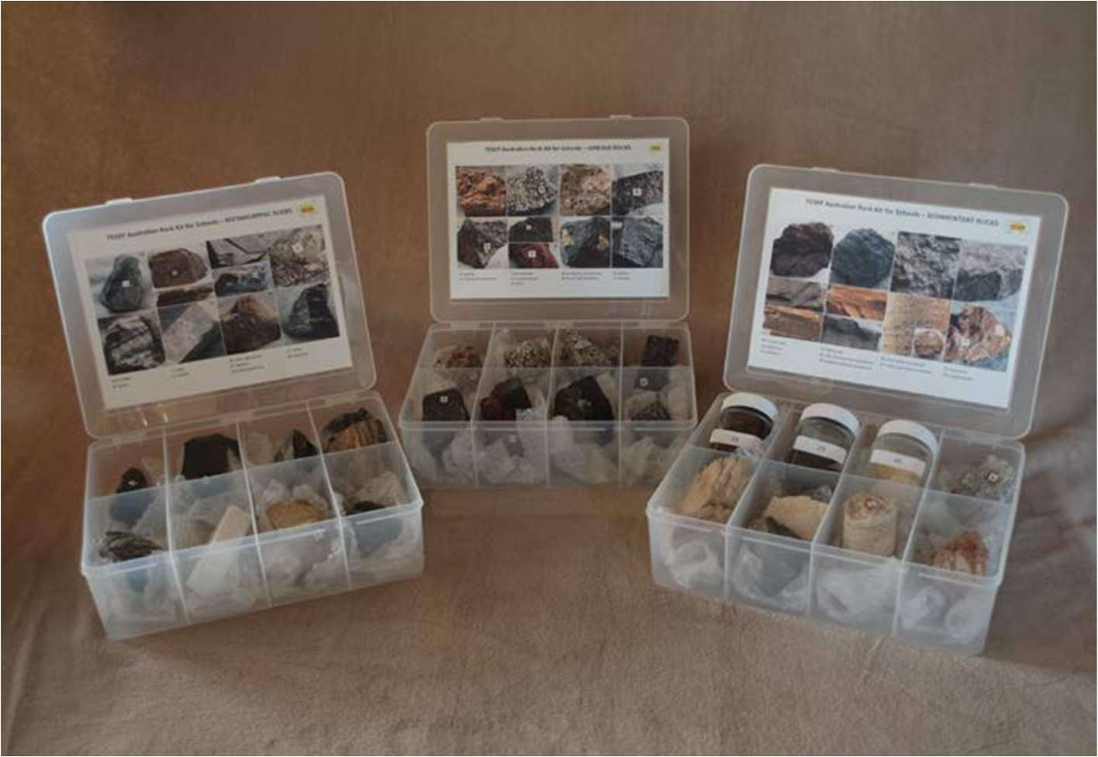

TESEP Aust. Rock Kit & Plate Tectonics poster

tesep.org.au

**Booking form**

|  |
| --- |
| Name: |
| School: |
| Teaching Area: |
| Phone (School): |
| Email: |
| Home postal address: |
|
| Special Dietary and other requirements: |
|

Professional Development Workshop Series in Earth and Environmental Science

|  |  |
| --- | --- |
| Email or fax form to ASTA (office – Josh Fartch). Send the non-refundable* registration fee (includes GST) to Australian Science Teachers Association (ABN 87 902 882 824).  Payment can be made by direct bank transfer or cheque/money order. Please include your name and workshop details with payment (e.g. TESEP PD9 NSW July 20 J. Citizen).  *The fee is transferable to another PD workshop or for another teacher to substitute | |
| Email: **office@asta.edu.au** | Address: TESEP - ASTA  PO Box 334 Deakin West ACT 2600 |
| Account Details: Australian Science Teachers Association (ASTA) BSB: 082 902 Account No: 556 705 700 | |
| Please tick here if you require an invoice ☐ and provide address if different from the one above: | |
| A certificate will be issued by ASTA which states the number of PD attendance hours. For registration inquiries contact registration@tesep.org.au  Please Note: Issuing of a certificate is conditional on workshop payment. | |
|

|  |
| --- |
| Registration fee: Free for teachers working at the host school and other sponsored schools. $50 per attendee for each other (non-sponsored) school. |

| please print clearly | |
| --- | --- |
| Workshop: Ashcroft HS, 2-PD Crit. Minerals & Life, Fossils & 5 Big Extinctions | Date: Thu 19 Dec 2024 |
| Venue: Ashcroft HS, 108 Maxwells Ave, Ashcroft, NSW 2168 | State: NSW |