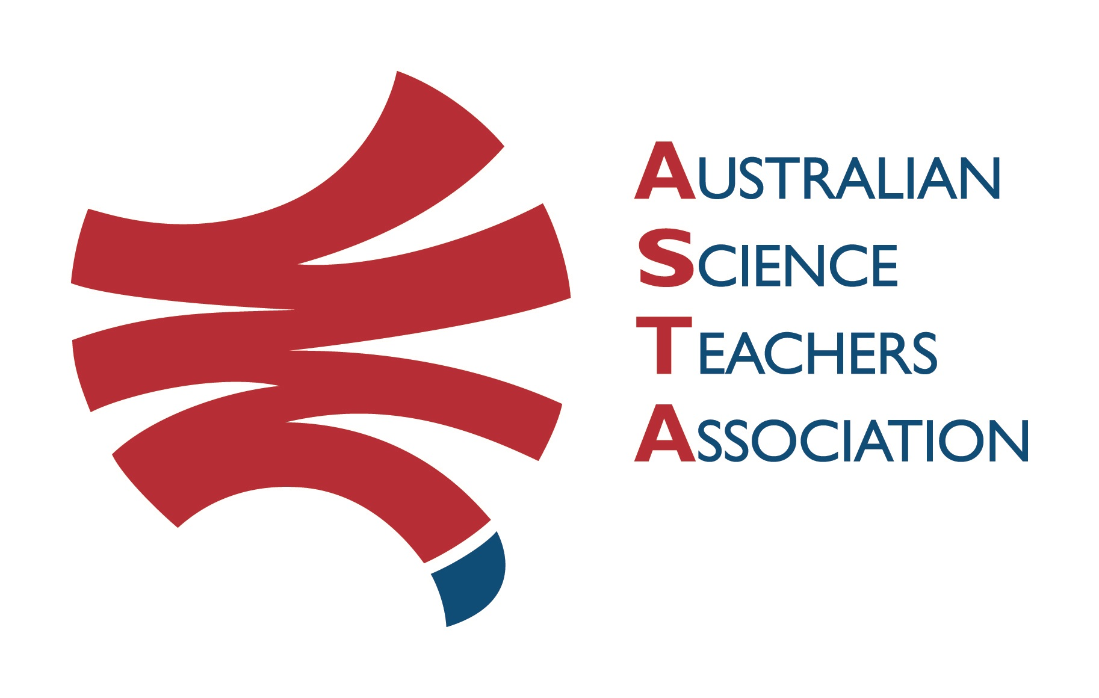
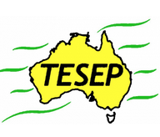

Professional Development Workshop Series in Earth and Environmental Science
TESEP PRESENTS: AFTER SCHOOL PROFESSIONAL DEVELOPMENT (PD)

Rocks (the teaching pack-rock kit) & Plate Tectonics
School: Pyramid Hill College, Pyramid Hill Vic
Meeting Room: front office will direct attendees to meeting room
Date: Thu 30 March 2023, 3:30pm-6:00pm, PD for Primary & Secondary School teachers Rocks & Plate Tectonics
School Facilitator: Lizzie Fox

The RocksExpo experience includes:
1. Incursions – classroom lessons with students and teachers.
2. PD workshops – professional development workshops for teachers (introducing teaching resources for the school classroom, FREE to host-school teachers).
3. Certificate of attendance – A certificate of hours and workshop outcomes will be issued.
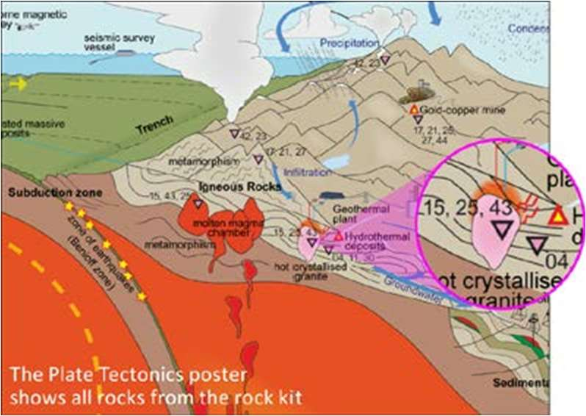
4. Introductory RocksExpo feature How to Use the Rock Kit and Teaching Pack (e.g. how to relate rock kit rocks to rock stories, 3D rendered samples, virtual thin sections and virtual outcrops).
Teacher Earth Science
Education Programme
5. Subsequent RocksExpo topics can be chosen from TESEP’s “The Challenging Earth” series (to
be run once a year at host schools).
6. Excursions – possible trip to field outcrops, mine sites, minerals museums etc.
Presenters:
Rob Kirk is a keen palaeontologist geologist, who has worked in industry as a consultant, travelling the world. His work in several states gives him many rock stories and samples to share.
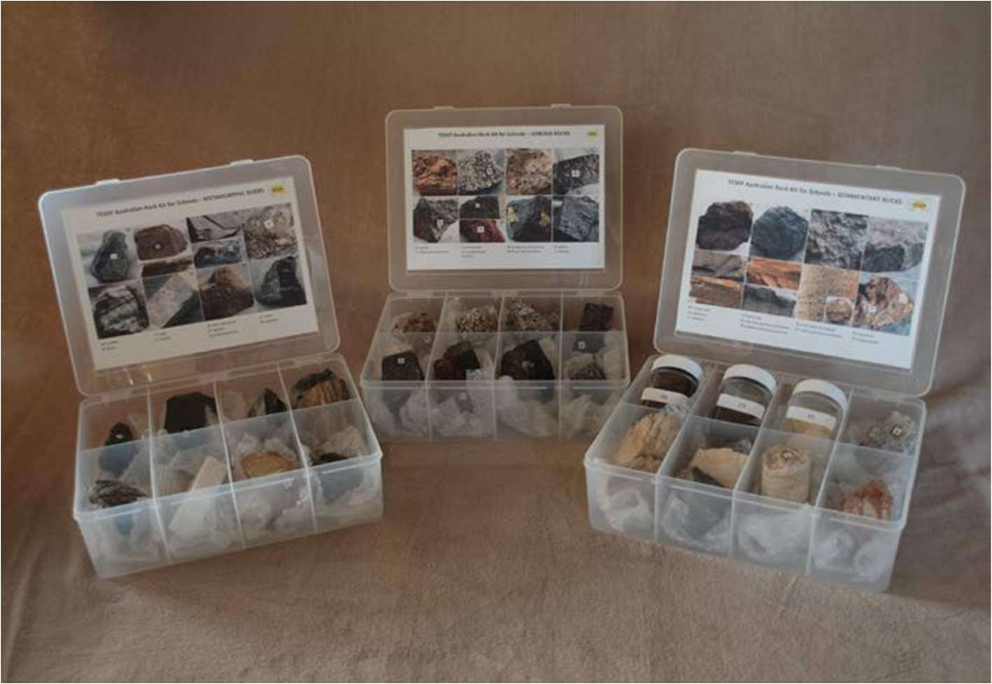

tesep.org.au

asta.edu.au
Booking form
Name:
School:
Teaching Area:
Phone (School):
Email:
Home postal address:
Special Dietary and other requirements:

Professional Development Workshop Series in Earth and Environmental Science
Email or fax form to ASTA (office manager – Michelle Lollback). Send the non-refundable* registration fee (includes GST) to Australian Science Teachers Association (ABN 87 902 882 824).
Payment can be made by direct bank transfer or cheque/money order. Please include your name and workshop details with payment (e.g. TESEP PD9 NSW July 20 J. Citizen).
*The fee is transferable to another PD workshop or for another teacher to substitute
Email: officemanager@asta.edu.au | Address: TESEP - ASTA  PO Box 334 Deakin West ACT 2600
Account Details: Australian Science Teachers Association (ASTA) BSB: 082 902 Account No: 556 705 700

Please tick here if you require an invoice ☐ and provide address if different from the one above:

A certificate will be issued by ASTA which states the number of PD attendance hours. For registration inquiries contact registration@tesep.org.au
Please Note: Issuing of a certificate is conditional on workshop payment.

Registration fee: Free for teachers working at the host school and Springsure area, primary schools.

please print clearly
Workshop: 2-PD Rocks (Rock Kit teaching pack), Plate Tectonics | a.m. Thu 30 March 2023
Venue: Pyramid Hill College, Pyramid Hill | State: Vic

