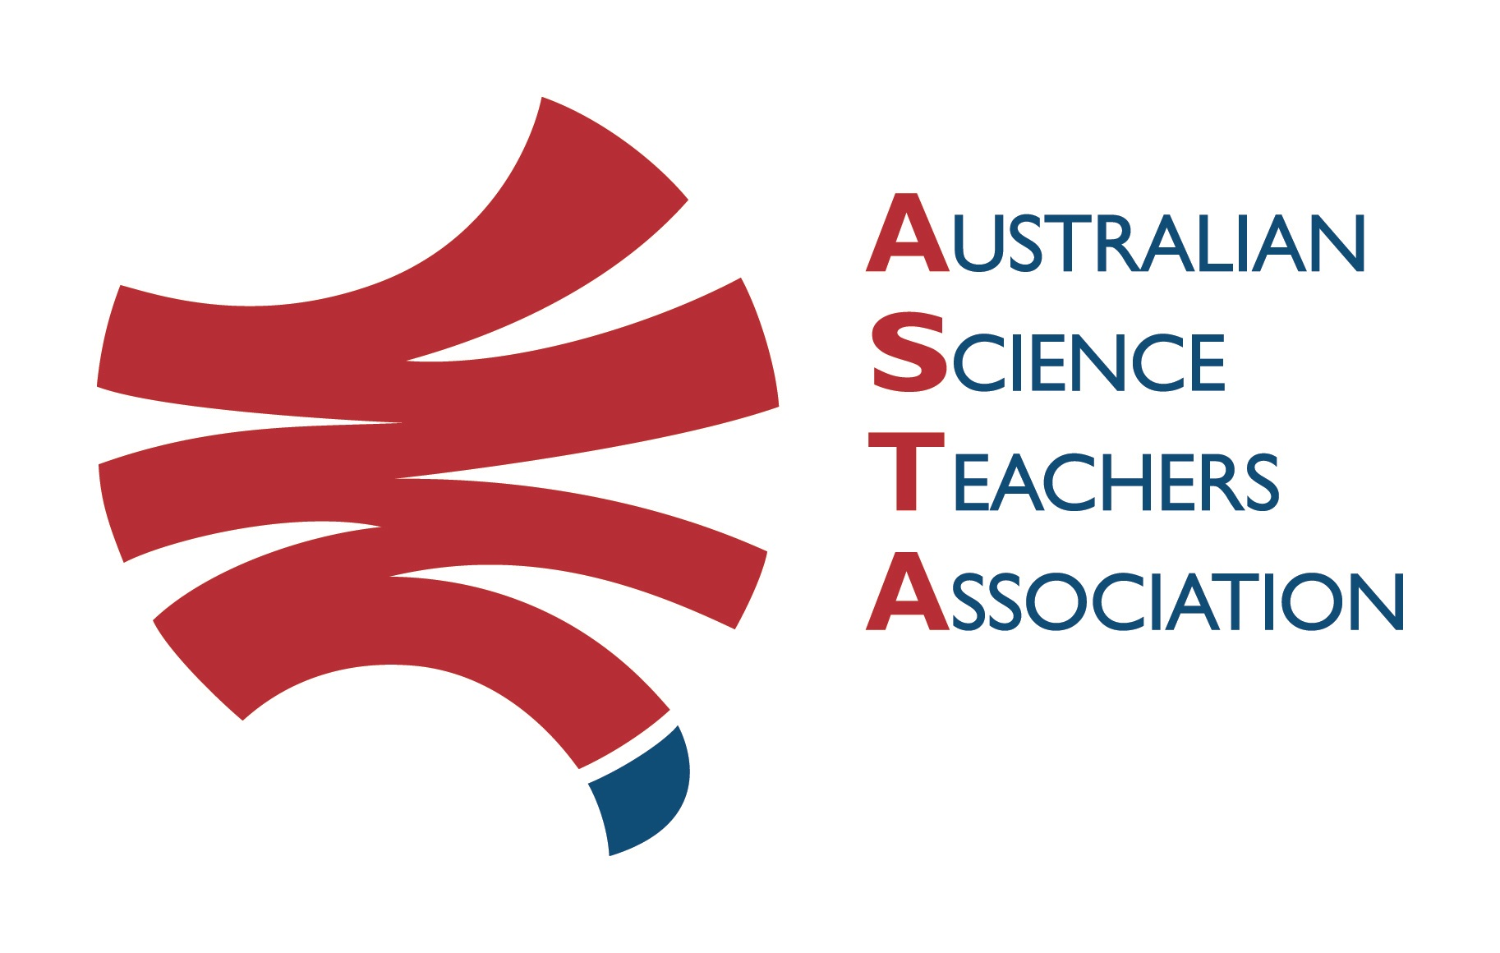
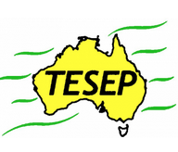

Professional Development Workshop Series in Earth and Environmental Science
TESEP PRESENTS: AFTER SCHOOL PROFESSIONAL DEVELOPMENT (PD)

RocksExpo 3-PD for teachers - presented by TESEP, in collaboration with the Australian Fossil and Mineral Museum, Bathurst
Critical Minerals (electric car, exploring/mining, recycling batteries etc)
Rocks (the Rock Kit Teaching Pack) & The Rock Cycle Game (& other teaching resources related to mining & rocks/minerals)
Wet Rocks (groundwater & artesian basin systems, the water cycle)
Venue: Aust. Fossil & Mineral Museum, 224 Howick St, Bathurst, NSW
Meeting Room: Mineral Gallery – tour the museum during breaks in the PD program
Date: Wed 10 May 2023,
Critical Minerals 1:00-2:30pm Rocks & Wet Rocks 2:45-5:30pm
Museum Facilitator: Penny Packham
3 X PD workshops – professional development workshops for teachers (@ $45 per attendee for 3-PD session).
Certificate of attendance (ASTA) – A certificate of hours and workshop outcomes will be issued, to those teacher attendees who provide feedback on the workshop & an email address.

Presenters:
Malte Ebach is an experienced fossil geologist (palaeontologist).
Katarina David is a keen hydro-geologist and Vlad David is a minerals geologist. All presenters have worked around the world. Their work in several states of Australia, gives them many exciting rock stories to share.
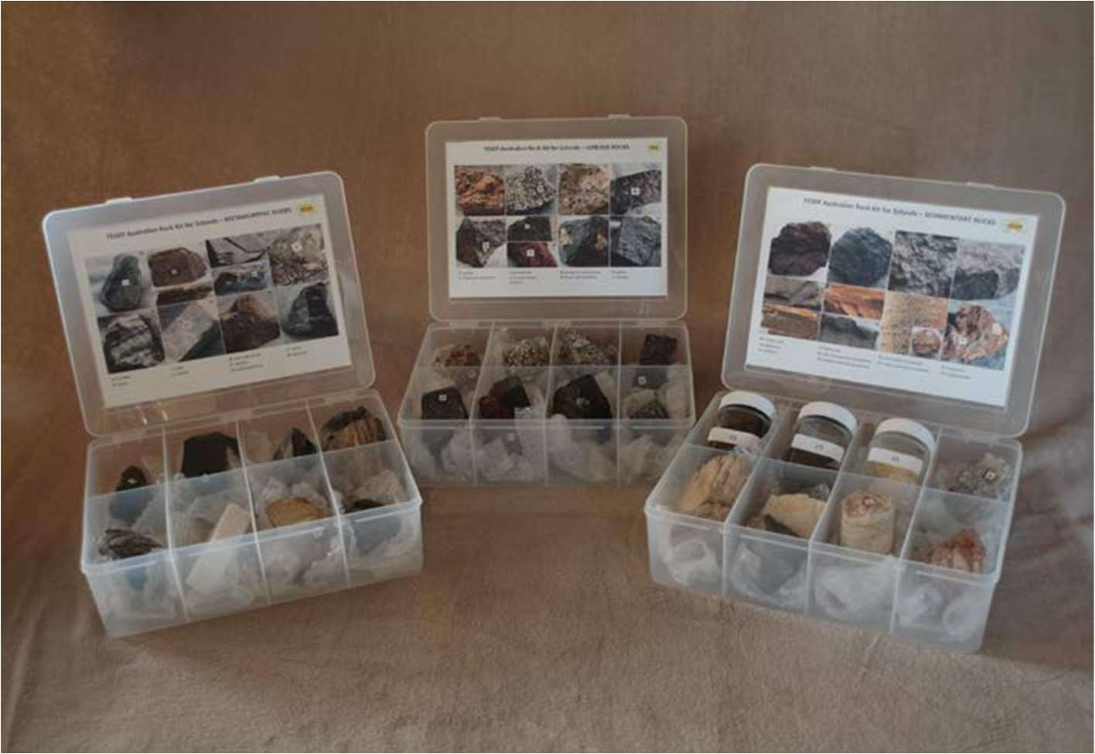

tesep.org.au

asta.edu.au
Booking form
Name:
School:
Teaching Area:
Phone (School):
Email:
Home postal address:
Special Dietary and other requirements:

Professional Development Workshop Series in Earth and Environmental Science
Email or fax form to ASTA (office manager – Michelle Lollback). Send the non-refundable* registration fee (includes GST) to Australian Science Teachers Association (ABN 87 902 882 824).
Payment can be made by direct bank transfer or cheque/money order. Please include your name and workshop details with payment (e.g. TESEP PD9 NSW July 20 J. Citizen).
*The fee is transferable to another PD workshop or for another teacher to substitute
Email: officemanager@asta.edu.au | Address: TESEP - ASTA  PO Box 334 Deakin West ACT 2600
Account Details: Australian Science Teachers Association (ASTA) BSB: 082 902 Account No: 556 705 700

Please tick here if you require an invoice ☐ and provide address if different from the one above:

A certificate will be issued by ASTA which states the number of PD attendance hours. For registration inquiries contact registration@tesep.org.au
Please Note: Issuing of a certificate is conditional on workshop payment & getting teacher email address & filled-in teacher feedback form.

Registration fee: $45 per attendee

please print clearly
Workshop: 3-PD Critical Minerals, Rocks (the Rock Kit teaching pack) & Wet Rocks | Date: Wed 10 May 2023
Venue: Aust Fossil & Mineral Museum, Bathurst | State: NSW

