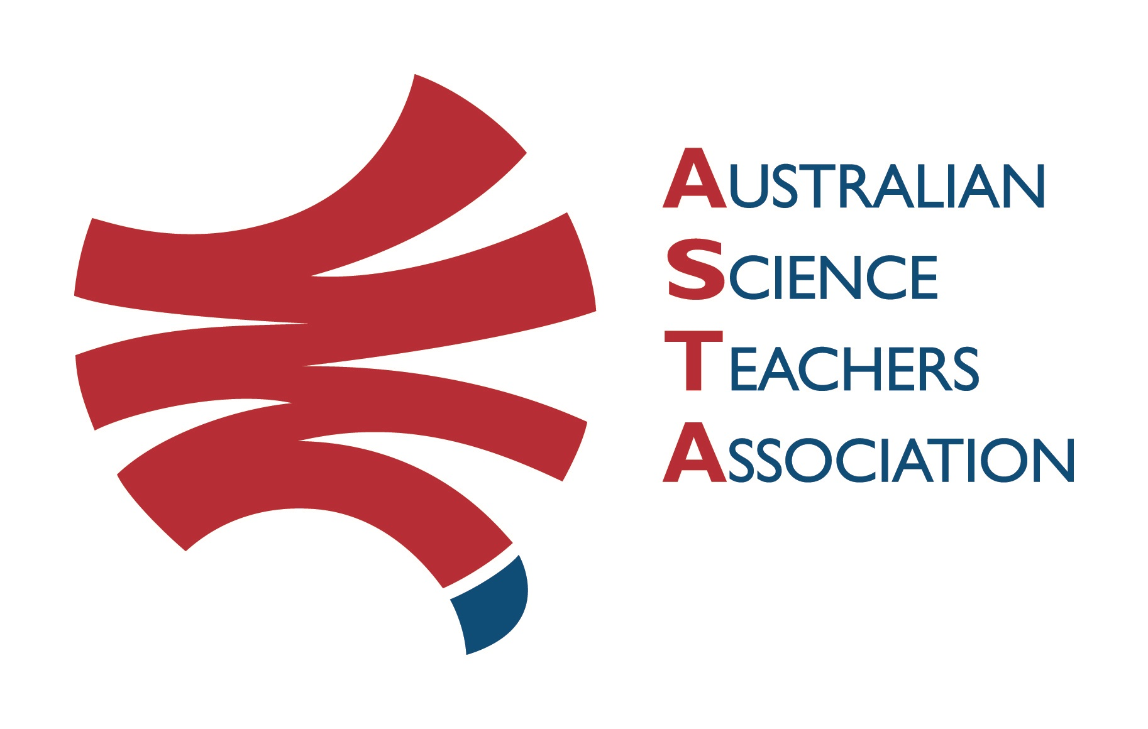
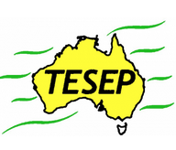

Professional Development Workshop Series in Earth and Environmental Science
TESEP PRESENTS: AFTER SCHOOL PROFESSIONAL DEVELOPMENT (PD)

RocksExpo 2-PD Introducing Our Dynamic Planet:
Volcanoes/Sth Grampians Fieldtrip - Sun 26 March 2023 &
Rocks (the Rock Kit Teaching Pack) & Plate Tectonics 2-PD
School: Baimbridge College, 59 Baimbridge Rd, Hamilton, Vic Meeting Room: Library
Date: Mon 27 March 2023, 3:40pm – 4:30pm Rocks, 4:30-6:00pm Plate Tectonics
School Facilitator: Yvette Colquhoun

The RocksExpo experience includes–
1. Incursions – classroom lessons with students and teachers.
2. PD workshops – After-school professional development workshops for teachers (1- to 2-PD sessions @ $25 per attendee for visiting teachers, FREE to host-school teachers).
3. Certificate of attendance – A certificate of hours and workshop outcomes will be issued.
4. FREE rock kit – Host to receive a FREE rock kit (palm-sized rocks) and Plate Tectonics poster.
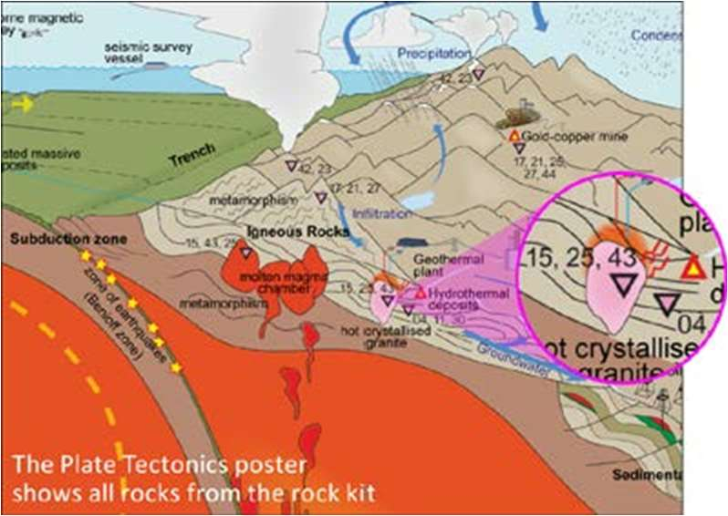
5. Introductory RocksExpo feature How to Use the Rock Kit and Teaching Pack (e.g. how to relate rock kit rocks to rock stories, 3D rendered samples, virtual thin sections and virtual outcrops).
Teacher Earth Science
Education Programme
6. Subsequent RocksExpo topics can be chosen from TESEP’s “The Challenging Earth” series (to
be run once a year at host schools).
7. Excursions – possible trip to local field outcrops (dev a guide for teachers) - on request
Presenters:
Rod Boucher is a keen ore geologist, who has worked in industry around Australia.
Stephen Carey is an experienced, palaeontologist educator who knows the region’s geology well.
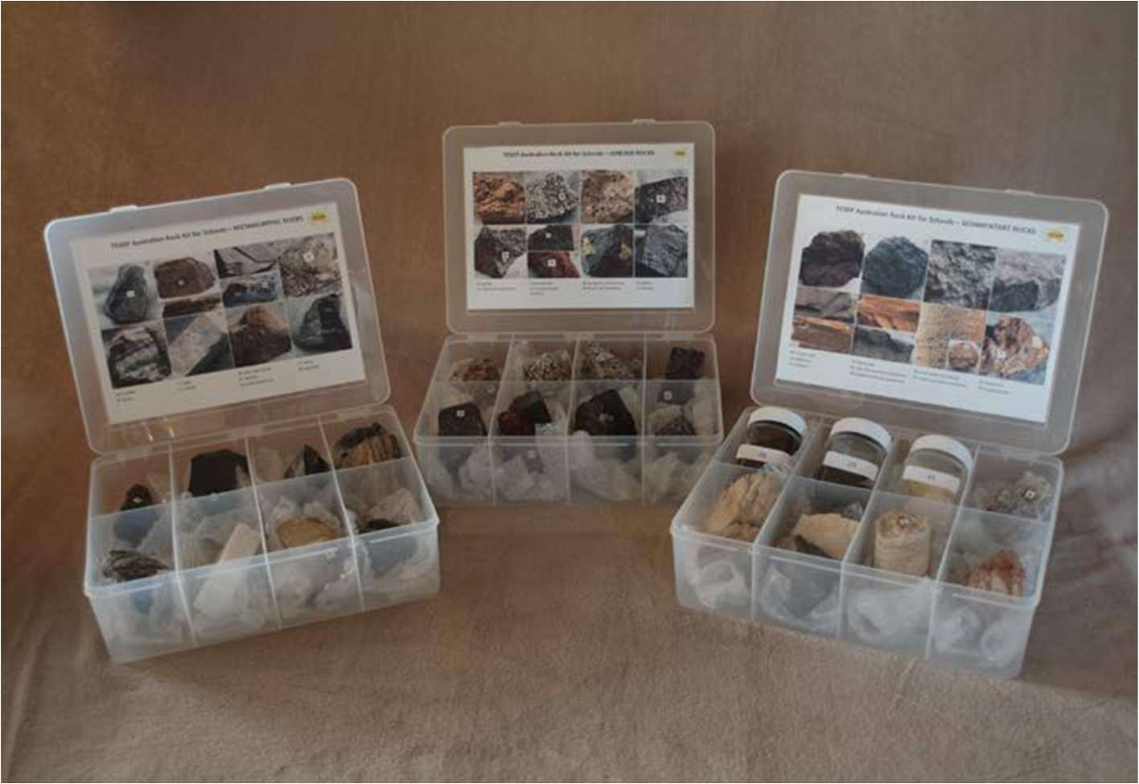

tesep.org.au

asta.edu.au
Booking form
Name:
School:
Teaching Area:
Phone (School):
Email:
Home postal address:
Special Dietary and other requirements:

Professional Development Workshop Series in Earth and Environmental Science
Email or fax form to ASTA (office manager – Michelle Lollback). Send the non-refundable* registration fee (includes GST) to Australian Science Teachers Association (ABN 87 902 882 824).
Payment can be made by direct bank transfer or cheque/money order. Please include your name and workshop details with payment (e.g. TESEP PD9 NSW July 20 J. Citizen).
*The fee is transferable to another PD workshop or for another teacher to substitute
Email: officemanager@asta.edu.au | Address: TESEP - ASTA  PO Box 334 Deakin West ACT 2600
Account Details: Australian Science Teachers Association (ASTA) BSB: 082 902 Account No: 556 705 700

Please tick here if you require an invoice ☐ and provide address if different from the one above:

A certificate will be issued by ASTA which states the number of PD attendance hours. For registration inquiries contact registration@tesep.org.au
Please Note: Issuing of a certificate is conditional on workshop payment.

Registration fee: Free for teachers working at the host school and other sponsored schools. $25 per attendee for each other (non-sponsored) school.

please print clearly
Workshop: Volcanoes/Sth Grampians Fieldtrip & 2-PD Rocks (the Rock Kit teaching pack) & Plate Tectonics | Date: Mon 27 Mar 2023
Venue: Baimbridge College, Hamilton, Vic, Library | State: VIC

