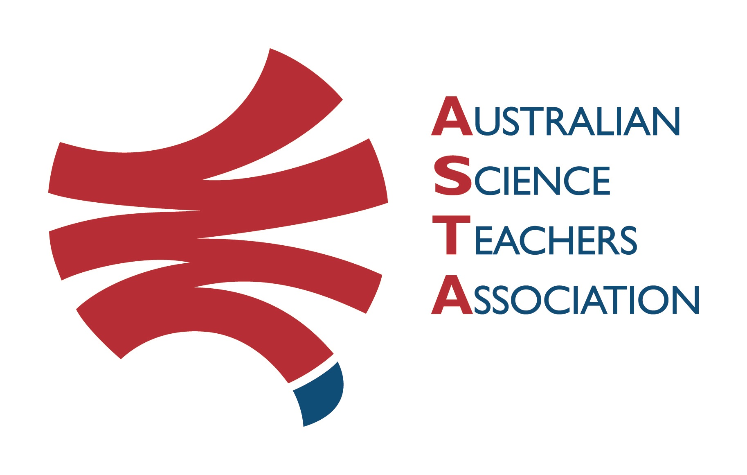
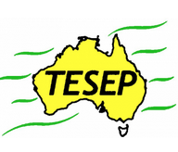

Professional Development Workshop Series in Earth and Environmental Science
TESEP PRESENTS: AFTER SCHOOL PROFESSIONAL DEVELOPMENT (PD)

Fieldtrip, Rock Stories, Hermidale/Aeris mine tour, (stories of the local rocks), Sat 18 Feb 8:15am–10:30am, meet outside Hermidale PS Mouramba St
3-PD Critical Minerals - Renewable Energy (magnets for wind turbines, solar panels, electric cars), Our Place in Space & Rocks (Rock Kit Teaching Pack) Sat 18 Feb 2023, 11:15am-5:15pm
School: Nyngan High School, 19 Cobar St, Nyngan Meeting Room: sign in at front office
Date: Sat 18 February 2023, 11:15am – 1:15pm Critical Minerals & Renewable Energy (electric cars/wind turbine magnets/touch screens, solar panels) ---lunch break ---, 1:45-3:30pm Our Place in Space 4:00-5:15pm Rocks & Rock Stories (& How to Use TESEP Rock Kit 3D renders, virtual thin sections, Rock Stories, virtual fieldtrip exposures) Facilitators: Emma Partridge/Benn Wright
The RocksExpo experience includes–
1. Incursions – classroom lessons with students and teachers.
2. PD workshops – After-school professional development workshops for teachers (1- to 2-PD sessions @ $25 per attendee for visiting teachers, FREE to host-school teachers).
3. ASTA Certificate of attendance – A certificate of hours and workshop outcomes will be issued.
4. FREE rock kit – Host to receive a FREE rock kit and Plate Tectonics poster.
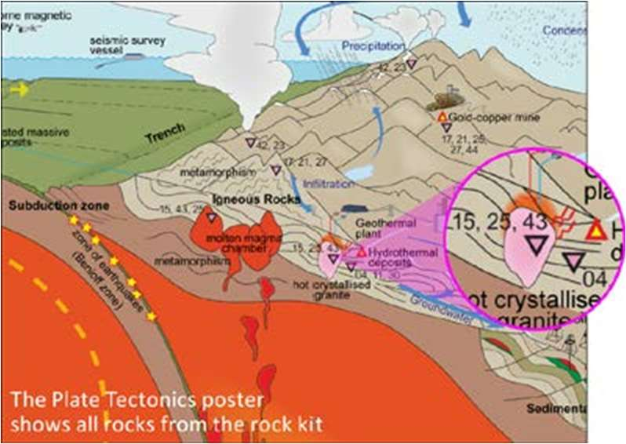
5. Introductory RocksExpo feature How to Use the Rock Kit and Teaching Pack (e.g. how to relate rock kit rocks to rock stories, 3D rendered samples, virtual thin sections and virtual outcrops).
Teacher Earth Science
Education Programme
6. Subsequent RocksExpo topics can be chosen from TESEP’s “The Challenging Earth” series
7. Excursions – possible trip to local field outcrops (dev a guide for teachers) - on request
Presenters: Phil Gilmore has expertise in geological mapping, the history of the Earth and minerals across Australia. Malte Ebach is an experienced sedimentary basin geologist. Their work in several states gives them many rock stories and samples to share.
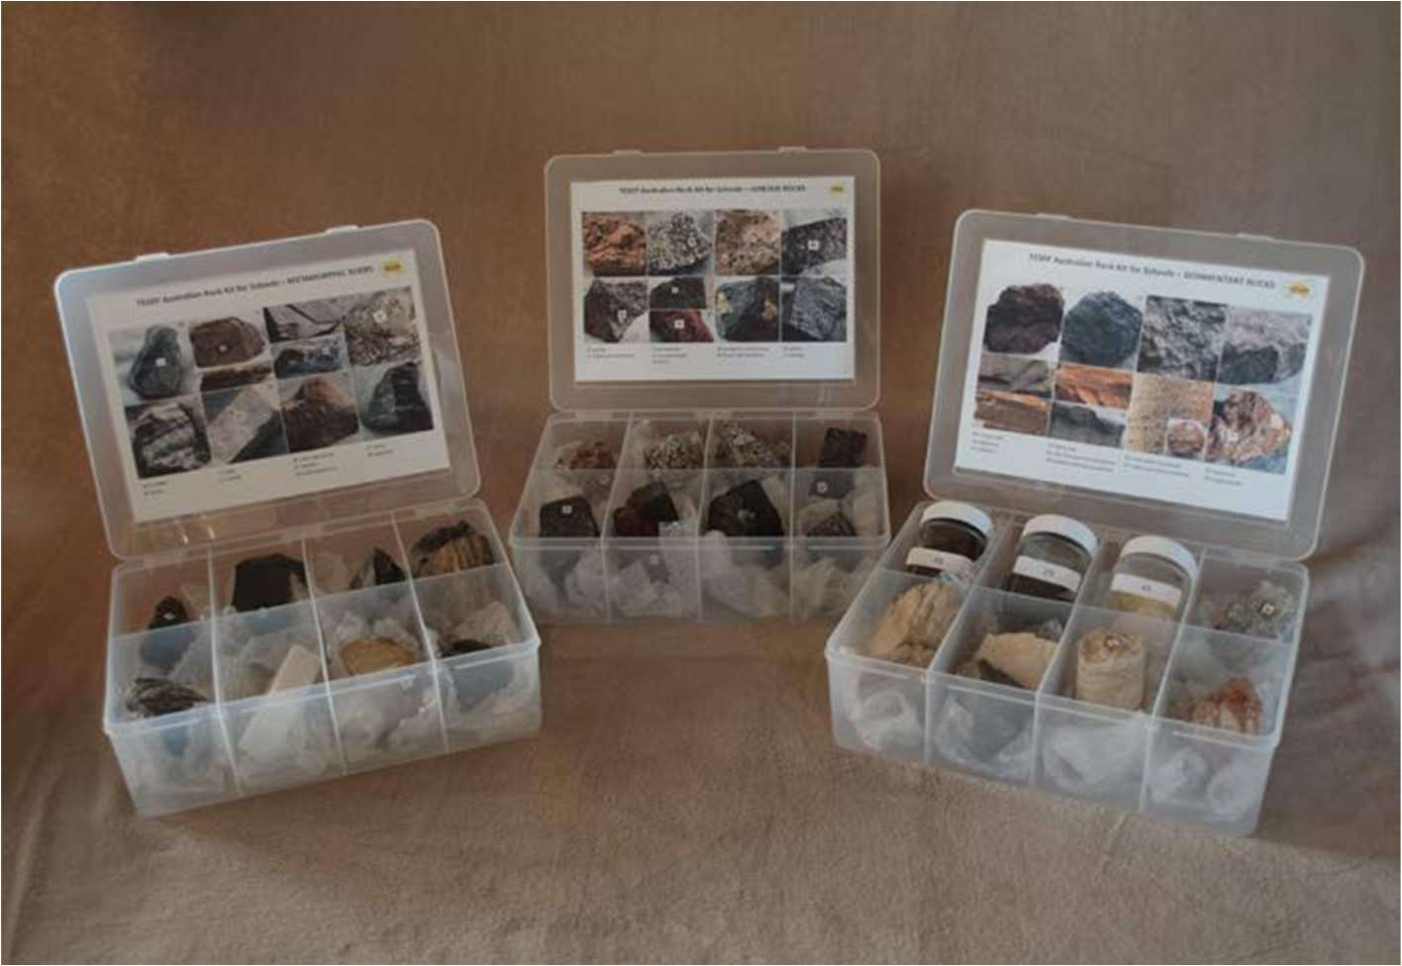

tesep.org.au

asta.edu.au
Booking form
Name:
School:
Teaching Area:
Phone (School):
Email:
Home postal address:
Special Dietary and other requirements:

Professional Development Workshop Series in Earth and Environmental Science
Email or fax form to ASTA (office manager – Michelle Lollback). Send the non-refundable* registration fee (includes GST) to Australian Science Teachers Association (ABN 87 902 882 824).
Payment can be made by direct bank transfer or cheque/money order. Please include your name and workshop details with payment (e.g. TESEP PD9 NSW July 20 J. Citizen).
*The fee is transferable to another PD workshop or for another teacher to substitute
Email: officemanager@asta.edu.au | Address: TESEP - ASTA  PO Box 334 Deakin West ACT 2600
Account Details: Australian Science Teachers Association (ASTA) BSB: 082 902 Account No: 556 705 700

Please tick here if you require an invoice ☐ and provide address if different from the one above:

A certificate will be issued by ASTA which states the number of PD attendance hours. For registration inquiries contact registration@tesep.org.au
Please Note: Issuing of a certificate is conditional on workshop payment.

Registration fee: Free for teachers working at the host school and other sponsored schools. $25 per attendee for each other (non-sponsored) school.

please print clearly
Workshop: 2-PD Critical Minerals, Our Place in Space & Rocks (Rock Kit teaching pack) | Date: Sat 18 Feb 2023
Venue: short local fieldtrip / mine tour Hermidale & 3-PD at Nyngan High School | State: NSW

