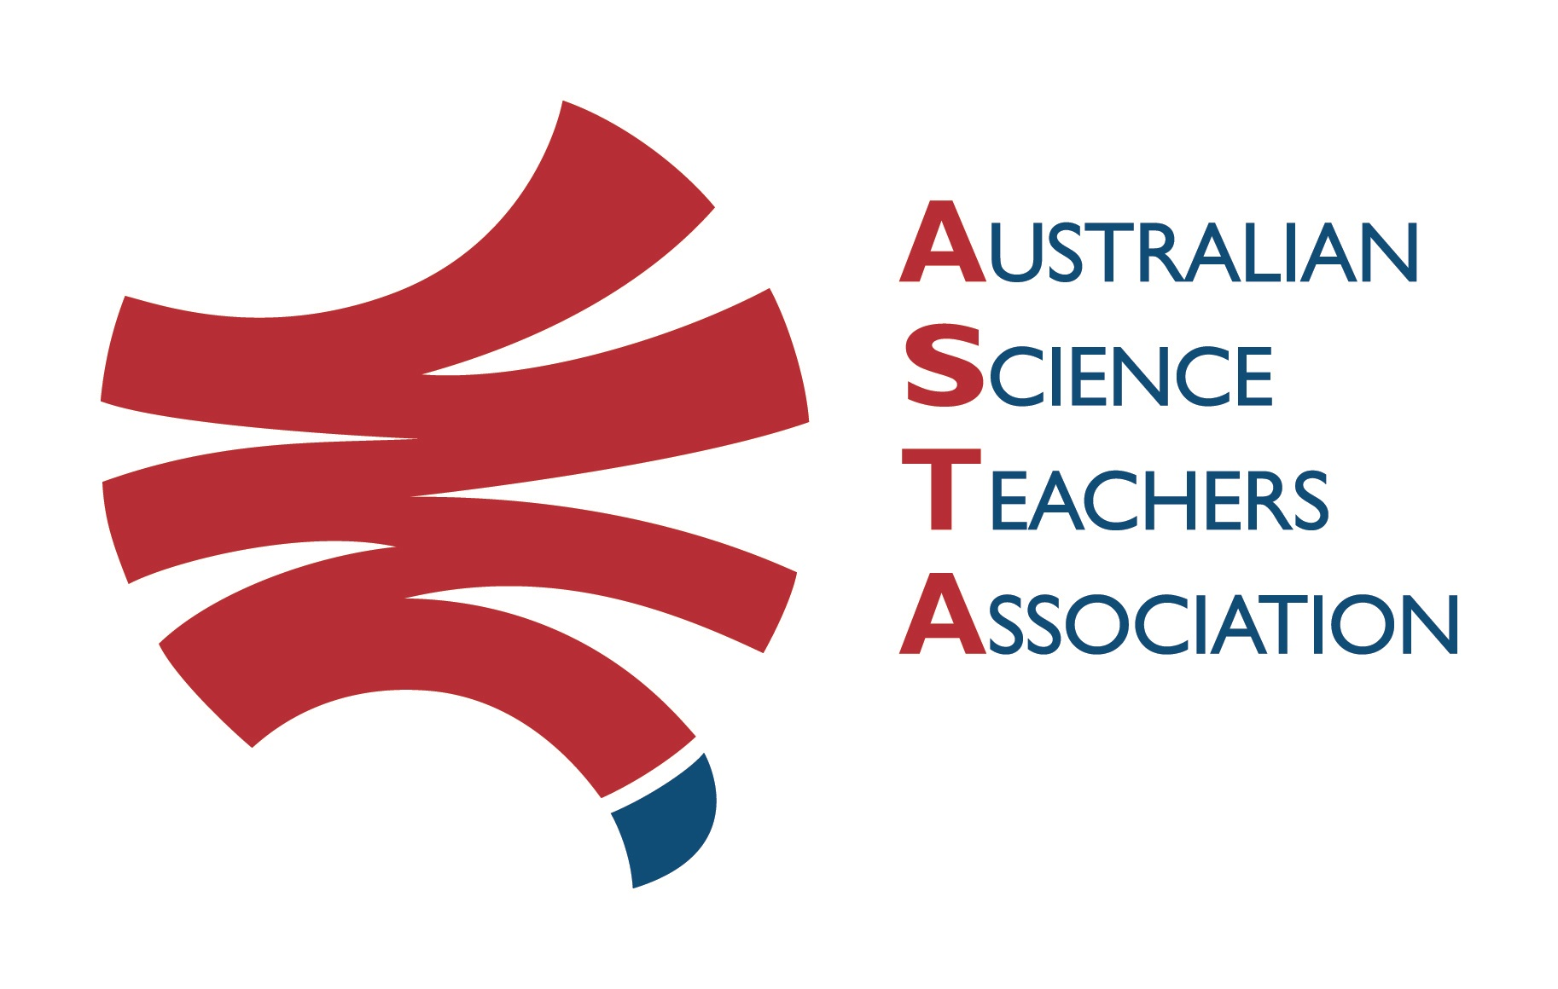
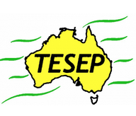

Professional Development Workshop Series in Earth and Environmental Science
TESEP PRESENTS: AFTER SCHOOL PROFESSIONAL DEVELOPMENT (PD)

Wet Rocks (water cycle, groundwater, artesian basins and porous/perm rocks)
School: Portland Central School, Wolgan St, Portland NSW
Meeting Room: Staff common room (visiting teachers please check in at front office for directions)
Date: Fri 4 Nov 2022, 7:30am-9:00am, PD Wet Rocks (Primary & Secondary School teachers)
School Facilitator: Leigh McLean
Fieldtrip, Rock Stories, Lithgow, session 2: Sat 5 Nov 9am-11am (stories of the rocks with worksheets with Q&A)
The RocksExpo experience includes:
1. Incursions – classroom lessons with students and teachers.
2. PD workshops – professional development workshops for teachers (introducing teaching resources for the primary school classroom, FREE to primary school teachers).
3. Certificate of attendance – A certificate of hours and workshop outcomes will be issued.
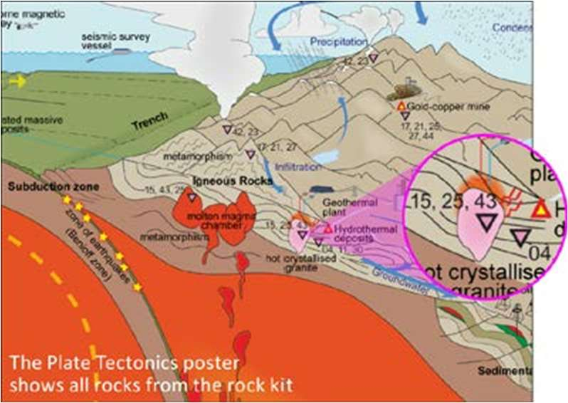
4. Introductory RocksExpo feature How to Use the Rock Kit and Teaching Pack (e.g. how to relate rock kit rocks to rock stories, 3D rendered samples, virtual thin sections and virtual outcrops).
Teacher Earth Science
Education Programme
5. Subsequent RocksExpo topics can be chosen from TESEP’s “The Challenging Earth” series (to
be run once a year at host schools).
6. Excursions – possible trip to field outcrops, mine sites, minerals museums etc.
Presenters:
Phil Gilmore is a keen ore geologist and Kevin Lanigan is an experienced sedimentary basin geologist. Their work in several states gives them many rock stories and samples to share.
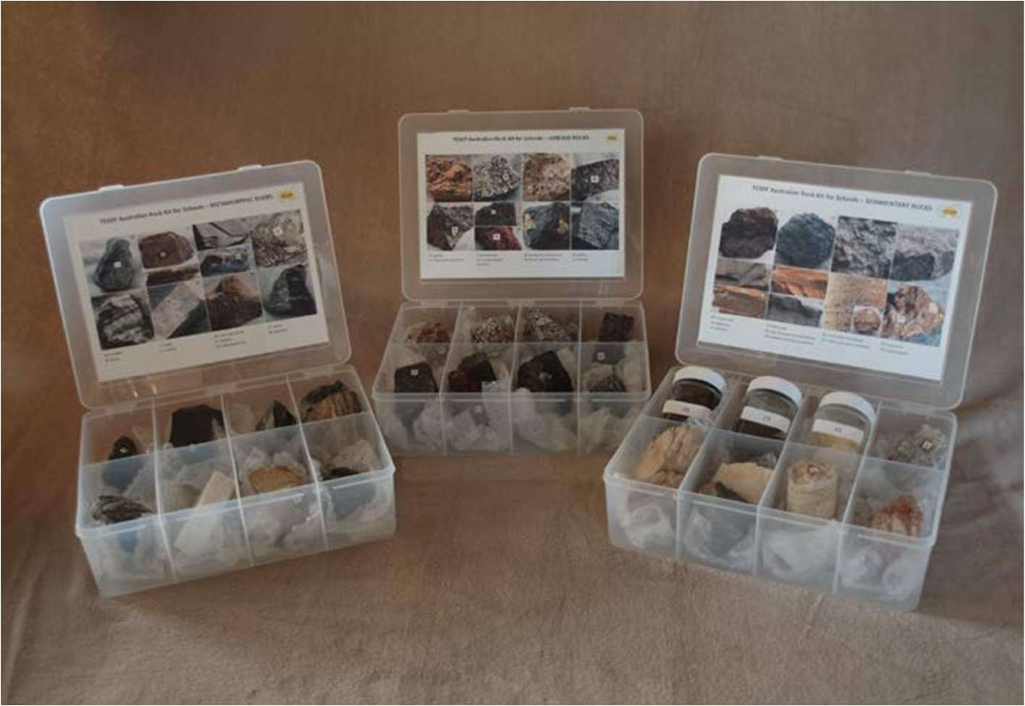

tesep.org.au

asta.edu.au

Name:
School:
Teaching Area:
Phone (School):
Email:
Home postal address:
Special Dietary and other requirements:
Booking form
Professional Development Workshop Series in Earth and Environmental Science
Email or fax form to ASTA (office manager – Michelle Lollback). Send the non-refundable* registration fee (includes GST) to Australian Science Teachers Association (ABN 87 902 882 824).
Payment can be made by direct bank transfer or cheque/money order. Please include your name and workshop details with payment (e.g. TESEP PD9 NSW July 20 J. Citizen).
*The fee is transferable to another PD workshop or for another teacher to substitute
Email: officemanager@asta.edu.au | Address: TESEP - ASTA  PO Box 334 Deakin West ACT 2600
Account Details: Australian Science Teachers Association (ASTA) BSB: 082 902 Account No: 556 705 700
Please tick here if you require an invoice ☐ and provide address if different from the one above:

A certificate will be issued by ASTA which states the number of PD attendance hours. For registration inquiries contact registration@tesep.org.au
Please Note: Issuing of a certificate is conditional on workshop payment.
Registration fee: Free for teachers working at the host school and Springsure area, primary schools.
please print clearly
Workshop: PD Wet Rocks | a.m. Fri 4 Nov 2022
Venue: Portland Central School, Portland (Please note fieldtrip session 2, that you are registering for) | State: NSW

