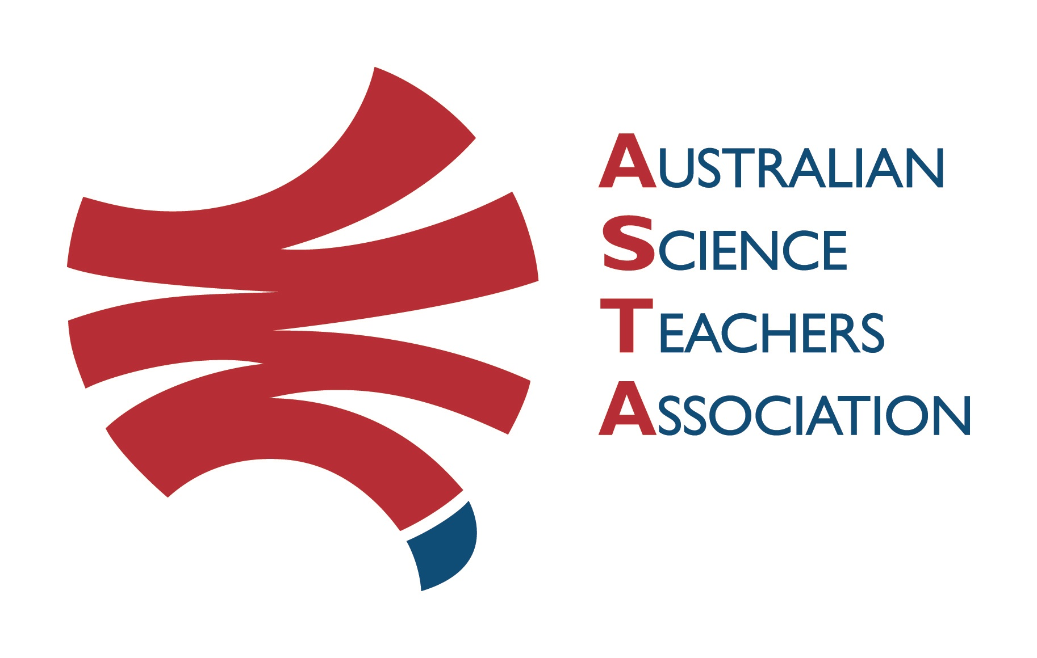
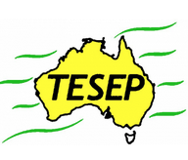

Professional Development Workshop Series in Earth and Environmental Science
TESEP PRESENTS: AFTER SCHOOL PROFESSIONAL DEVELOPMENT (PD)

RocksExpo 2-PD Introducing Our Dynamic Planet:
Rocks (Rock Kit Teaching Pack), Natural Hazards & Volcanoes
School: Hermidale Public School, Mouramba St, Hermidale Meeting Room: Infant Library
Date: Fri 9 Dec 2022, 3:30pm-6:00pm, PD for Primary School teachers (Nyngan region)
Fri 9 Dec 7:45am-9:30am or Sat 10 Dec 9am-11am – Fieldtrip (2 sessions) – rock stories of town outcrops with an experienced geologist &/or mine site visit
School Facilitator: Rebekah Harris

The RocksExpo experience includes:
1. Incursions – classroom lessons with students and teachers.
2. PD workshops – professional development workshops for teachers (introducing teaching resources for the primary school classroom, FREE to primary school teachers).
3. Certificate of attendance – A certificate of hours and workshop outcomes will be issued.
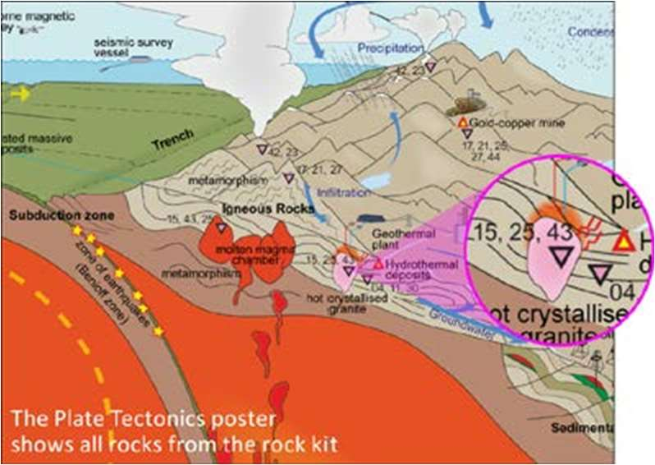
4. Introductory RocksExpo feature How to Use the Rock Kit and Teaching Pack (e.g. how to relate rock kit rocks to rock stories, 3D rendered samples, virtual thin sections and virtual outcrops).
Teacher Earth Science
Education Programme
5. Subsequent RocksExpo topics can be chosen from TESEP’s “The Challenging Earth” series (to
be run once a year at host schools).
6. Excursions – possible trip to field outcrops, mine sites, minerals museums etc.
Presenters:
Phil Gilmore has expertise in geological mapping, the history of the Earth and minerals across Australia.
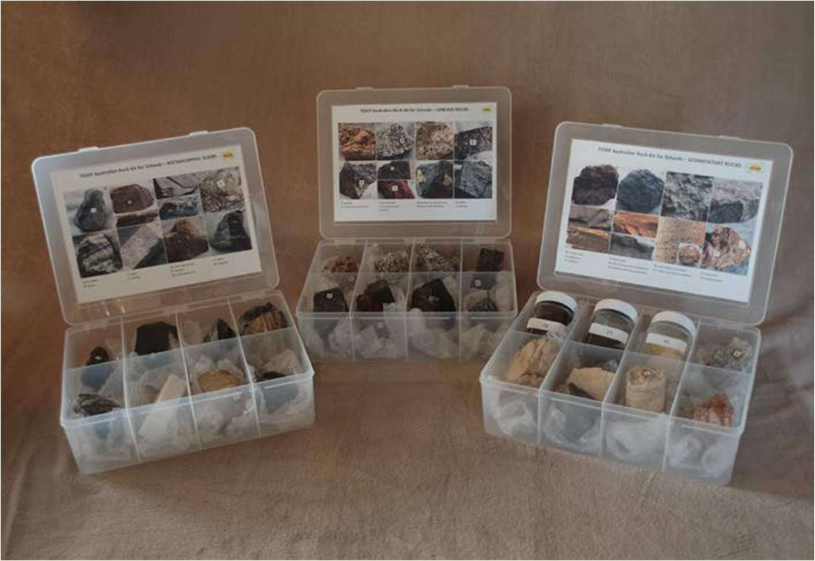

tesep.org.au

asta.edu.au

Name:
School:
Teaching Area:
Phone (School):
Email:
Home postal address:
Special Dietary and other requirements:

Booking form
Professional Development Workshop Series in Earth and Environmental Science
Email or fax form to ASTA (office manager – Michelle Lollback). Send the non-refundable* registration fee (includes GST) to Australian Science Teachers Association (ABN 87 902 882 824).
Payment can be made by direct bank transfer or cheque/money order. Please include your name and workshop details with payment (e.g. TESEP PD9 NSW July 20 J. Citizen).
*The fee is transferable to another PD workshop or for another teacher to substitute
Email: officemanager@asta.edu.au | Address: TESEP - ASTA  PO Box 334 Deakin West ACT 2600
Account Details: Australian Science Teachers Association (ASTA) BSB: 082 902 Account No: 556 705 700
Please tick here if you require an invoice ☐ and provide address if different from the one above:
A certificate will be issued by ASTA which states the number of PD attendance hours. For registration inquiries contact registration@tesep.org.au
Please Note: Issuing of a certificate is conditional on workshop payment.

Registration fee: Free for teachers working at the host school and Springsure area, primary schools.

please print clearly
Workshop: 2-PD Rocks (Rock Kit teaching pack), Volcanoes/Natural Hazards | a.m. Fri 9 Dec 2022
Venue: Hermidale Public School, Hermidale | State: NSW

