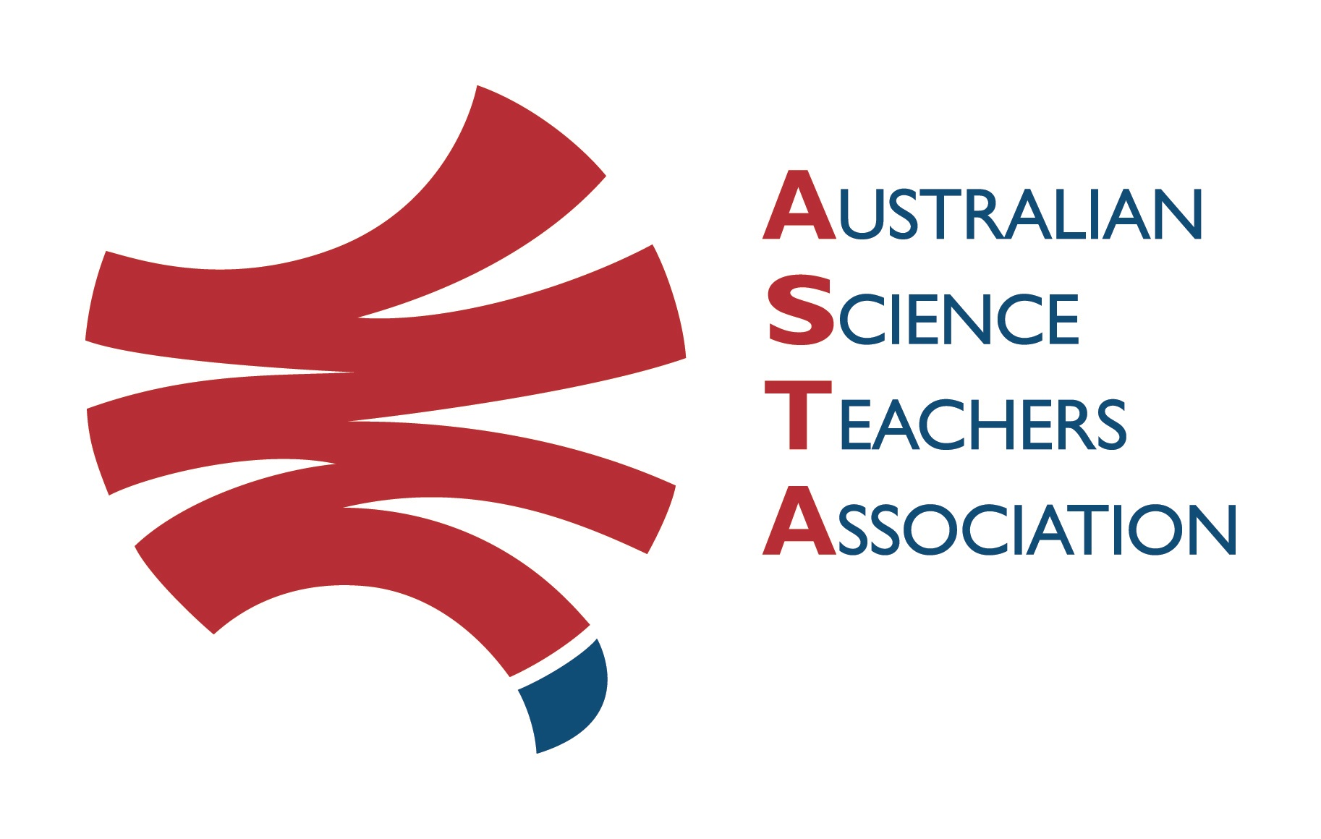
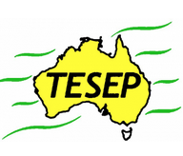

Professional Development Workshop Series in Earth and Environmental Science
TESEP PRESENTS: AFTER SCHOOL PROFESSIONAL DEVELOPMENT (PD)

Tue 5 March 2024, 1:45pm-7:15pm 5-short primary-oriented PDs
Rocks (Rock Kit Teaching Pack, Plate Tectonics poster exercise)
Water Cycle & Wet Rocks (artesian water, porous rock exercise)
Our Place in Space (incl. Mars-Earth landform & other exercises)
Critical Minerals & Renewable Energy – electric car/recycling
Local Fossils & Explorer Box Exercise for SA (local geology of the region, sponge cake exercise, explorer box, videos)
Host School: Loxton Lutheran School, 6 Luther Rd, Loxton SA
Meeting Room: go to front desk to be directed to STEM meeting room Facilitator: Karl Klose
The RocksExpo experience includes– (with light supper)
1. Incursions – classroom lessons with students and teachers & 2. PD workshops – for teachers
3. ASTA Certificate of attendance – A certificate of hours and workshop outcomes will be issued.
4. FREE rock kit – Host to receive a FREE rock kit and Plate Tectonics poster.
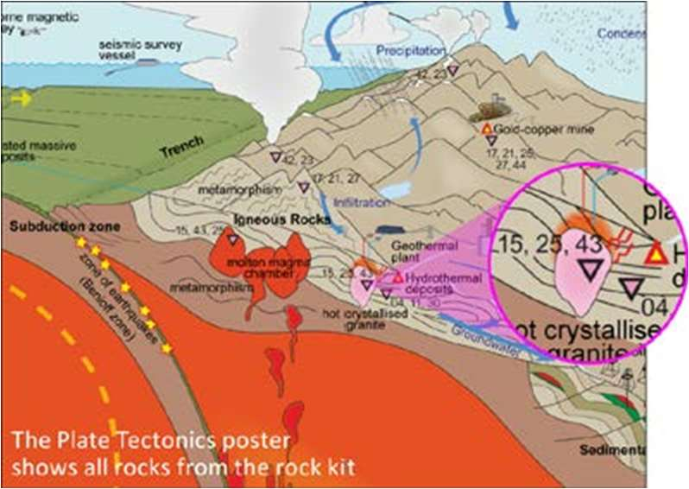
5. Introductory RocksExpo feature How to Use the Rock Kit and Teaching Pack (e.g. how to relate rock kit rocks to rock stories, 3D rendered samples, virtual thin sections and virtual outcrops).
Teacher Earth Science
Education Programme
6. Subsequent RocksExpo topics can be chosen from TESEP’s “The Challenging Earth” series 2
Presenters: Rod Boucher, is an experienced gold exploration geologist. Glen Nash is an experienced energy and minerals geologist – both are educators in the stories of Earth history.
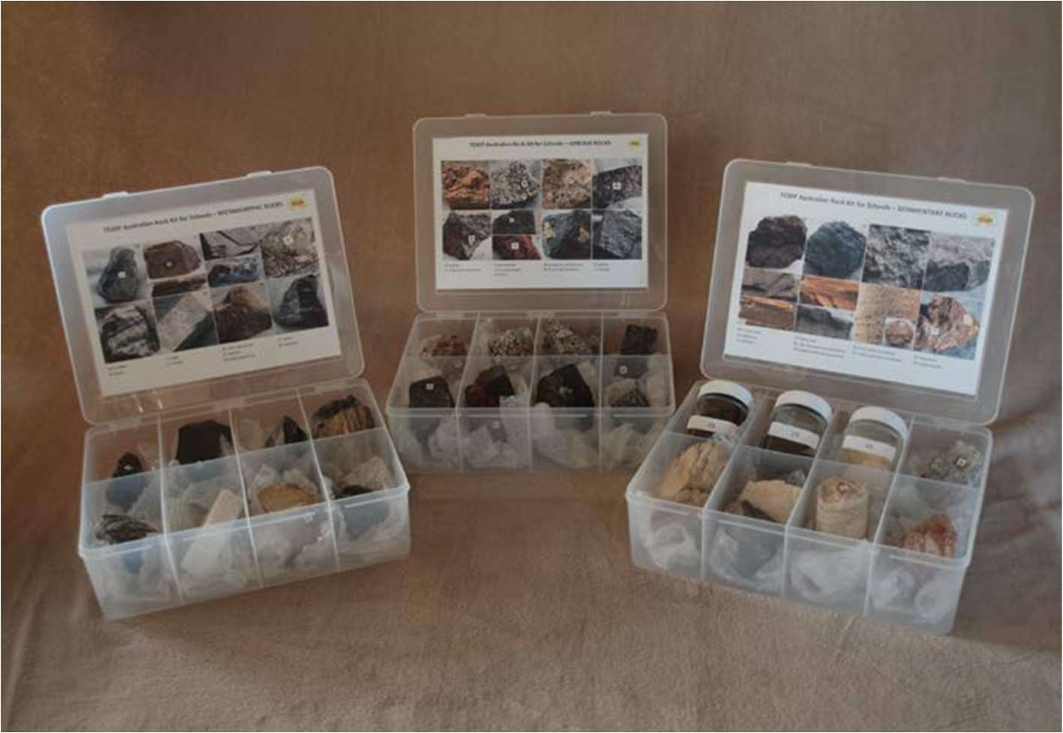

tesep.org.au

asta.edu.au
Booking form
Name:
School:
Teaching Area:
Phone (School):
Email:
Home postal address:
Special Dietary and other requirements:

Professional Development Workshop Series in Earth and Environmental Science
Email or fax form to ASTA (office manager – Michelle Lollback). Send the non-refundable* registration fee (includes GST) to Australian Science Teachers Association (ABN 87 902 882 824).
Payment can be made by direct bank transfer or cheque/money order. Please include your name and workshop details with payment (e.g. TESEP PD9 NSW July 20 J. Citizen).
*The fee is transferable to another PD workshop or for another teacher to substitute
Email: officemanager@asta.edu.au | Address: TESEP - ASTA  PO Box 334 Deakin West ACT 2600
Account Details: Australian Science Teachers Association (ASTA) BSB: 082 902 Account No: 556 705 700

Please tick here if you require an invoice ☐ and provide address if different from the one above:

A certificate will be issued by ASTA which states the number of PD attendance hours. For registration inquiries contact registration@tesep.org.au
Please Note: Issuing of a certificate is conditional on workshop payment.

Registration fee: Free for teachers working at the host school and other sponsored schools. $55 per attendee for each other (non-sponsored) school.

please print clearly
Workshop: Loxton - short primary-oriented 5-PDs - Rocks, Wet Rocks, Space, Critical Minerals/Electric car, Fossils of SA, (local geology, with exercises) | Date: Tue 05 March 2024
Venue: Loxton Lutheran School, Loxton | State: SA

