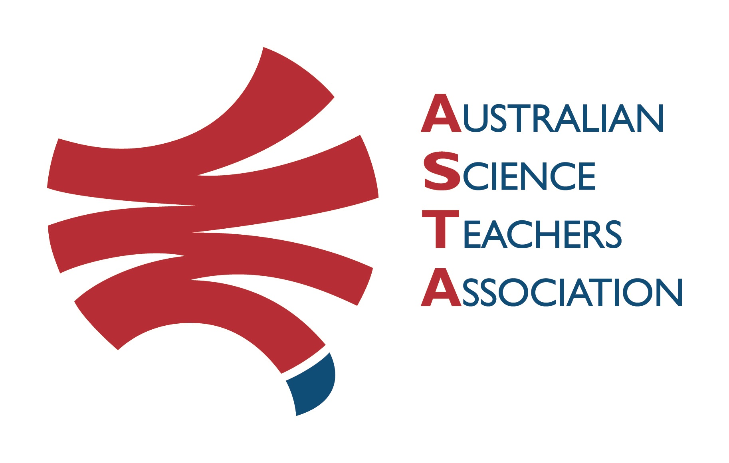
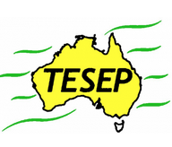

Professional Development Workshop Series in Earth and Environmental Science
TESEP PRESENTS: AFTER SCHOOL PROFESSIONAL DEVELOPMENT (PD)

RocksExpo 2-PD Introducing Our Dynamic Planet: 2:30-6:30pm Fri 9 Aug’24
Rocks (and how to use the TESEP rock kit)
Plate Tectonics (the tectonic Earth history)
Critical Minerals (e-car, wind turbine magnets, solar panels, recycling)
School: Clare HS, Elliott St, Clare, SA
Meeting Room: sign in at front desk & get directed (STEM Meeting Room)
Date: Fri 09 August 2024,
2:30pm – 3:20pm Rocks (Rock Kit Teaching Pack & integrated Plate Tectonics story, yr8),
3:30-4:30pm Plate Tectonics (tectonic Earth history, mountain-building, volcanic events, extinctions), supper break,
4:45pm – 6:30pm Critical Minerals (Renewables, electric car) School Facilitator: Ryan O’Neill

The RocksExpo experience includes–
1. Incursions – classroom lessons with students and teachers.
2. PD workshops – After-school professional development workshops for teachers (4-hour, 3-PD sessions @ $45 per attendee for visiting teachers, FREE to host-school teachers).
3. Certificate– Australian Science Teacher Association (ASTA) PD - Certificate of Attendance.
4. FREE rock kit – Host to receive a FREE rock kit and Plate Tectonics poster.
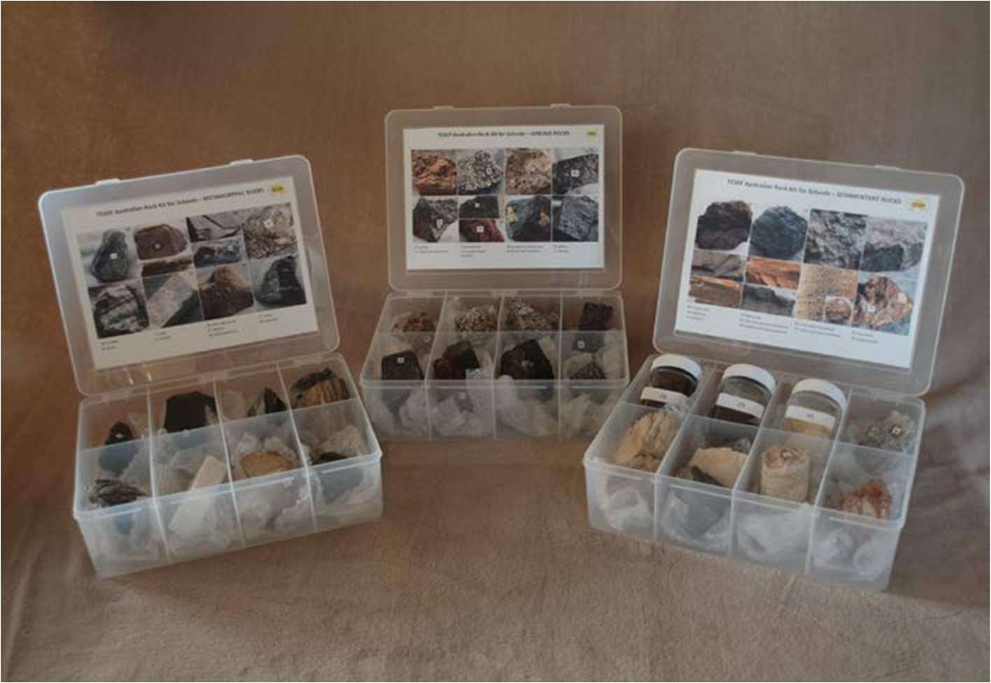
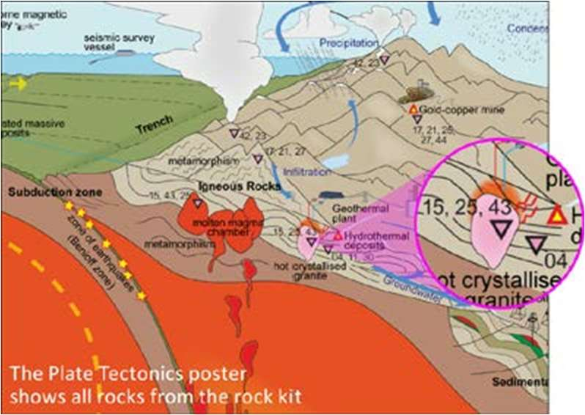
5. Introductory RocksExpo feature How to Use the Rock Kit and Teaching Pack (e.g. how to relate rock kit rocks to rock stories, 3D rendered samples, virtual thin sections and virtual outcrops).
Presenter:Philip Sansom is a keen and very experienced sedimentary basin geologist, with many a geo-story to tell from his work in the energy industry and his 30+ years as a secondary school science educator.
Teacher Earth Science
Education Programme

tesep.org.au

asta.edu.au
Booking form
Professional Development Workshop Series in Earth and Environmental Science
Name:
School:
Teaching Area:
Phone (School):
Email:
Home postal address:
Special Dietary and other requirements:

Registration fee: Free for teachers working at the host school and other sponsored schools. $45 per attendee from each other school.

please print clearly
Workshop: Clare SA 3-PD Rocks, Plate Tectonics and Critical Minerals | Date: Fri 09 August 2024
Venue: Clare HS, Clare SA | State: SA

Email or fax form to ASTA (office manager – Michelle Lollback). Send the non-refundable* registration fee (includes GST) to Australian Science Teachers Association (ABN 87 902 882 824).
Payment can be made by direct bank transfer or cheque/money order. Please include your name and workshop details with payment (e.g. TESEP PD9 NSW July 20 J. Citizen).
*The fee is transferable to another PD workshop or for another teacher to substitute
Email: officemanager@asta.edu.au | Address: TESEP ℅ ASTA  PO Box 334 Deakin West ACT 2600
Account Details: Australian Science Teachers Association (ASTA) BSB: 082 902 Account No: 556 705 700

Please tick here if you require an invoice ☐ and provide address if different from the one above:

A certificate will be issued by ASTA which states the number of PD attendance hours. For registration inquiries contact registration@tesep.org.au
Please Note: Issuing of a certificate is conditional on workshop payment & feedback survey completion.

