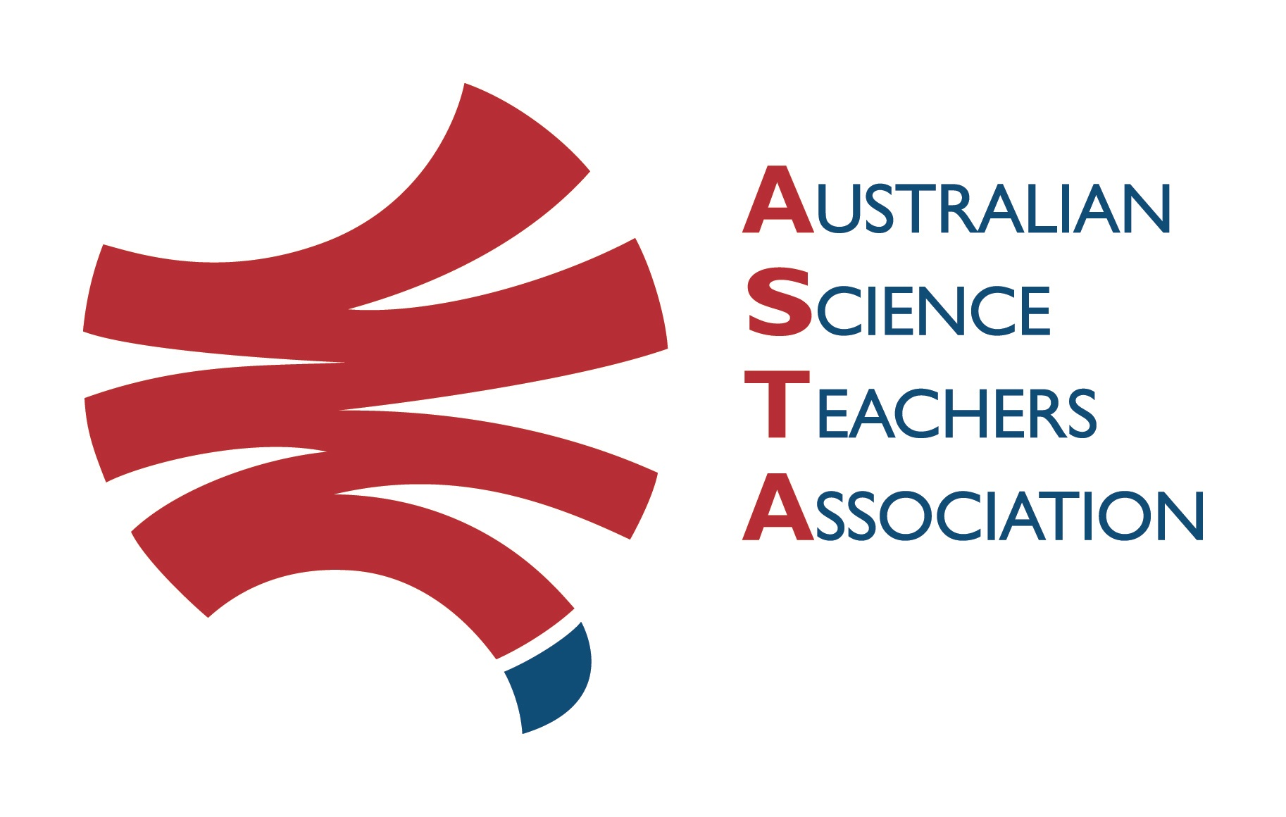
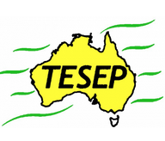

Professional Development Workshop Series in Earth and Environmental Science
TESEP PRESENTS: AFTER SCHOOL PROFESSIONAL DEVELOPMENT (PD)

4-PD Rocks/Rock Kit, Plate Tectonics/integrated story, Riding the Climate Rollercoaster, Fossils & the 5 Big Extinctions (with Rock Kit Teaching Pack, Plate Tectonics poster, videos & hands-on exercises)
School: St Francis of Assisi College, 260 Twentyfirst St, Renmark SA
Meeting Room: sign in at front office, get directions to the meeting room
Date: Wed 6 March 2024, 1:00pm – 5:00pm Facilitator: Natalie Meuret
Rocks (rock kit teaching pack) (TESEP Rock Kit 3D renders, virtuals, tour of the Plate Tectonics poster (new curriculum year 8 focus) & integrated story - Plate Tectonics 1pm-2pm, Tea Break
Riding the Climate Rollercoaster (climate drivers, ocean-atmosphere interactions, planetary influences, cycles through geologic time) 2:15pm-3:30pm – year 9-12 focus, Tea Break
Fossils & the 5 Big Extinctions (year 10-12 focus) (extinctions & fauna/flora changes related to plate tectonics/climate/volcanic events etc 3:40-5pm – year 9-12 focus
The RocksExpo experience includes–
1. Incursions – classroom lessons with students and teachers.
2. PD workshops – Professional development workshops for teachers (4-PD sessions @ $55 per attendee for visiting teachers, FREE to host-school teachers).
3. ASTA Certificate of attendance – A certificate of hours and workshop outcomes will be issued.
4. FREE rock kit – Host to receive a FREE rock kit and Plate Tectonics poster.
5. Introductory RocksExpo feature How to Use the Rock Kit and Teaching Pack
6. Subsequent RocksExpo topics can be chosen from TESEP’s “The Challenging Earth” series
Presenters: Rod Boucher & others - All TESEP educators are educators in the stories of Australia’s fossil & Earth history, with experience in the geology of many states of Australia.
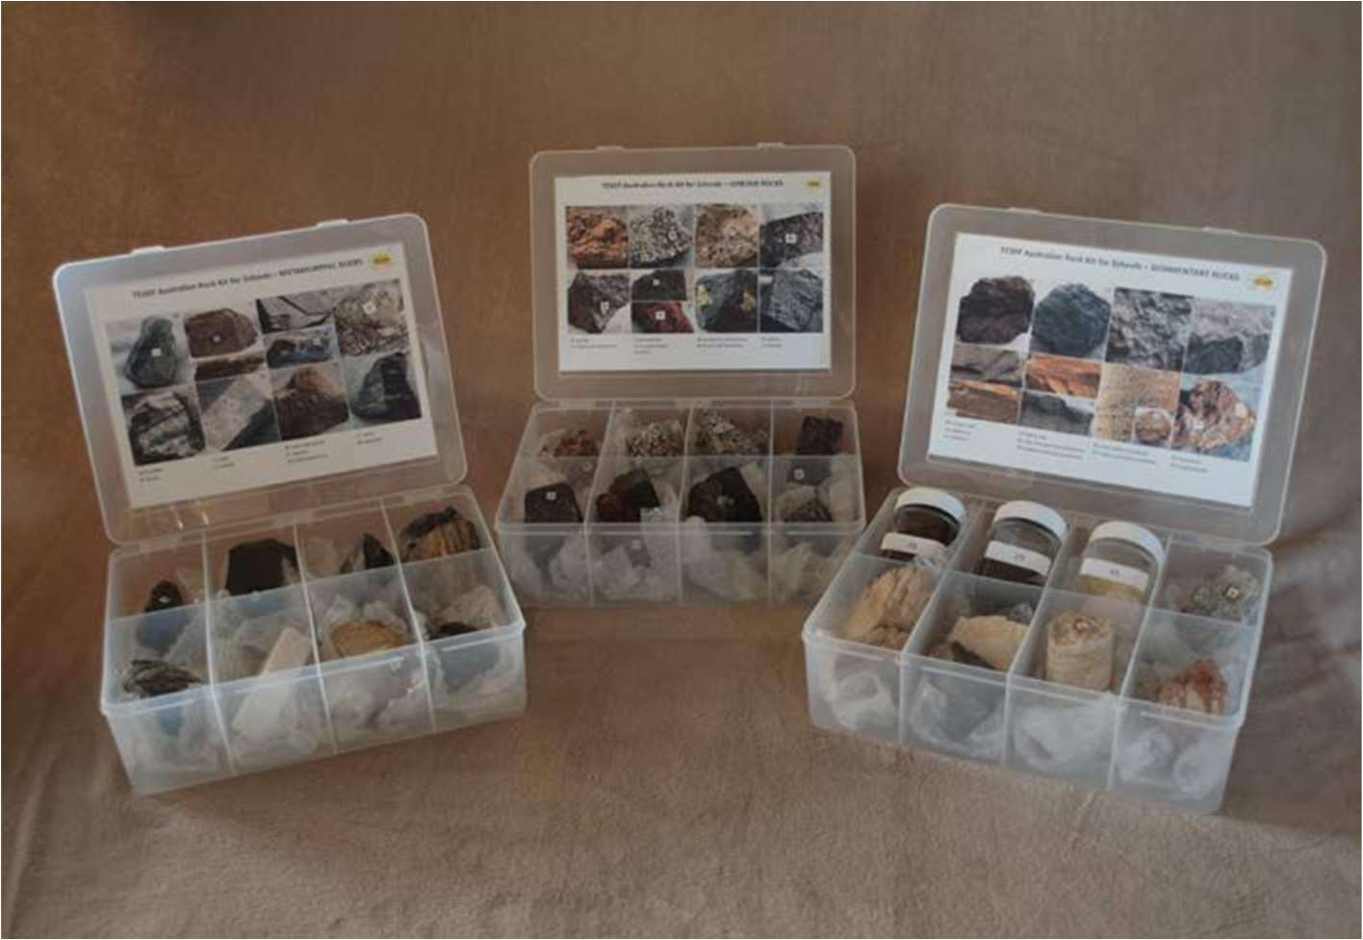
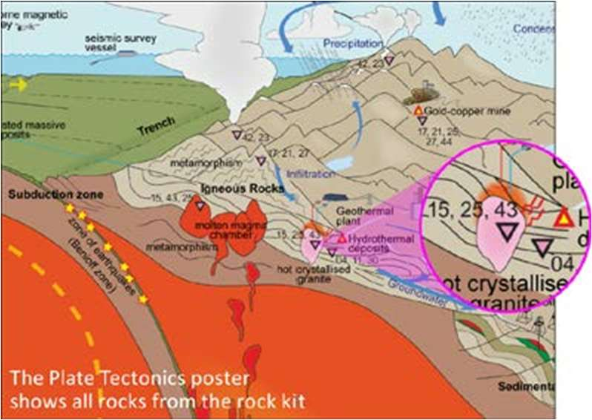

tesep.org.au

asta.edu.au
Booking form
Name:
School:
Teaching Area:
Phone (School):
Email:
Home postal address:
Special Dietary and other requirements:

Professional Development Workshop Series in Earth and Environmental Science
Email or fax form to ASTA (office manager – Michelle Lollback). Send the non-refundable* registration fee (includes GST) to Australian Science Teachers Association (ABN 87 902 882 824).
Payment can be made by direct bank transfer or cheque/money order. Please include your name and workshop details with payment (e.g. TESEP PD9 NSW July 20 J. Citizen).
*The fee is transferable to another PD workshop or for another teacher to substitute
Email: officemanager@asta.edu.au | Address: TESEP - ASTA  PO Box 334 Deakin West ACT 2600
Account Details: Australian Science Teachers Association (ASTA) BSB: 082 902 Account No: 556 705 700

Please tick here if you require an invoice ☐ and provide address if different from the one above:

A certificate will be issued by ASTA which states the number of PD attendance hours. For registration inquiries contact registration@tesep.org.au
Please Note: Issuing of a certificate is conditional on workshop payment.

Registration fee: Free for teachers working at the host school. $55 fee for attendance for each non-host school attendee, (includes supper).

please print clearly
Workshop: Renmark SA 4-PD Integrated Rocks & Plate Tectonics, Climate Rollercoaster , Fossils/Extinctions | Date: Mon 06 March 2024
Venue: St Francis of Assisi College, Renmark | State: SA

